1. Local User

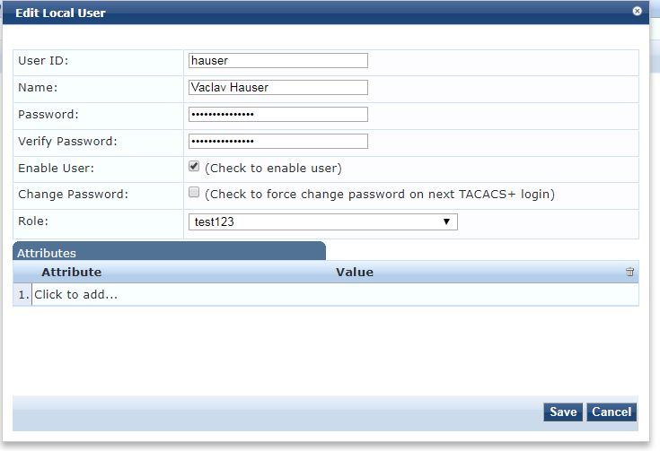

1. Operator profile

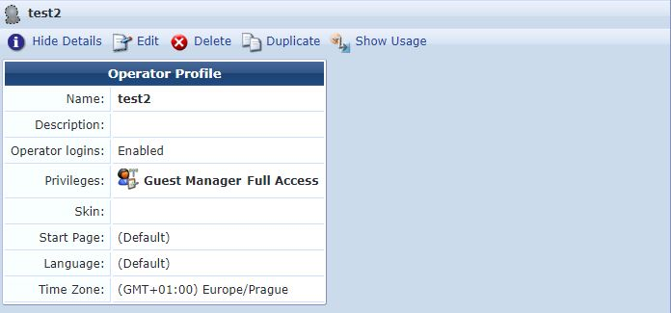

1. Enforcement profile

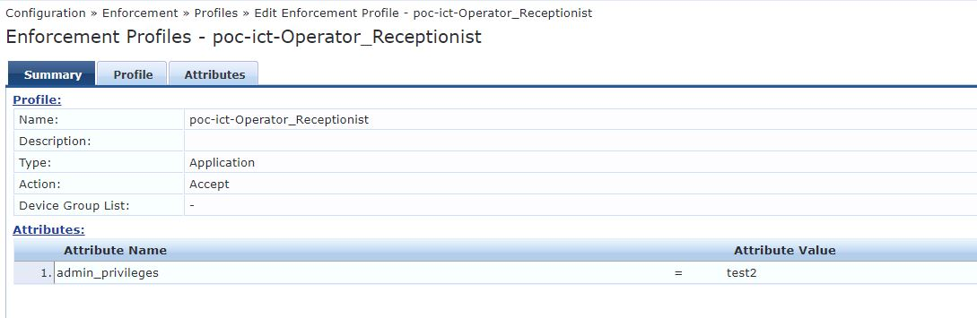

1. Enforcement Policy

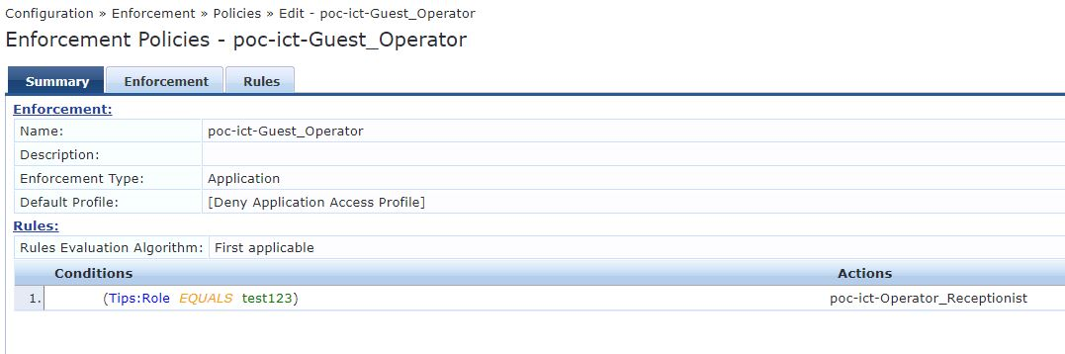

1. Role Mapping

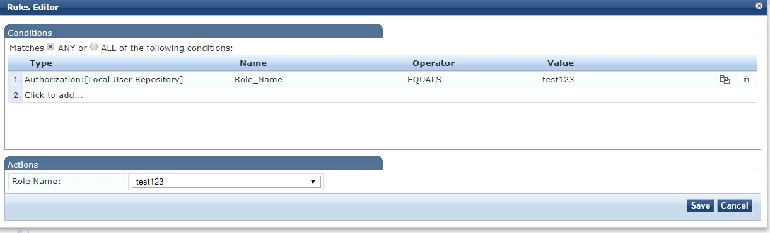

1. Service

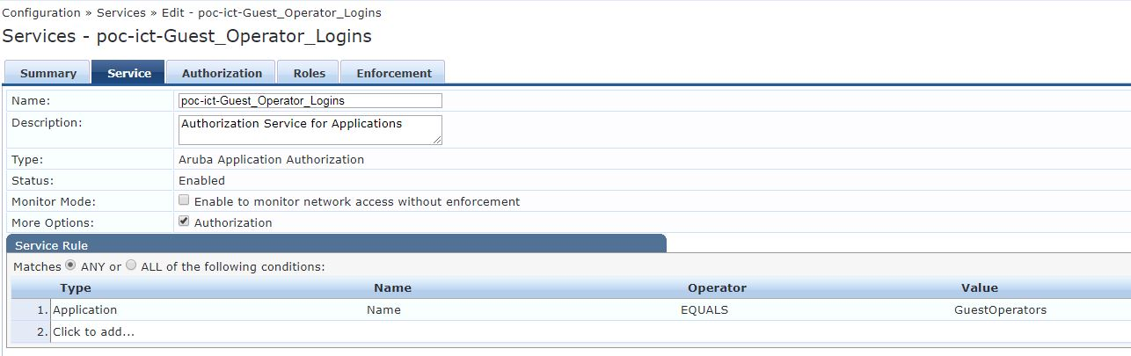

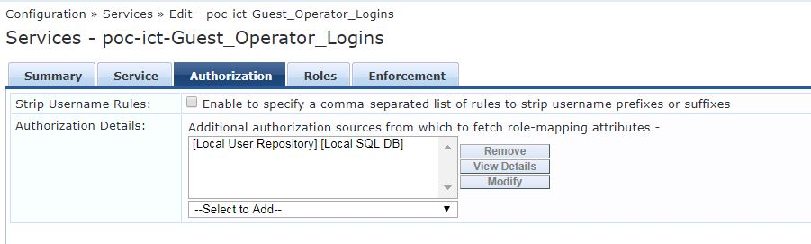

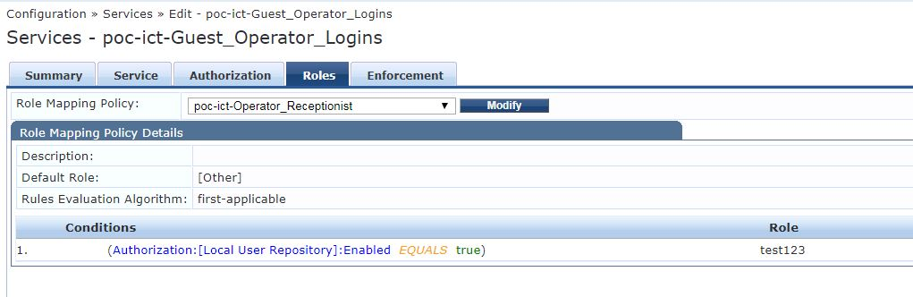

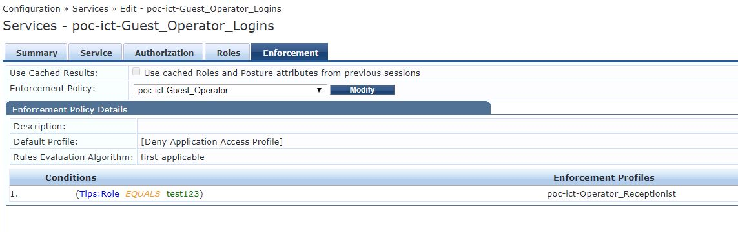

1. Operator login

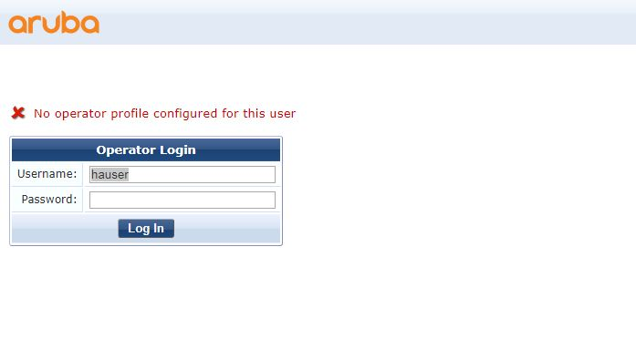

1. Access tracer

