EAP-TLS Termination

Termination of EAP-TLS on Aruba OS 3.1
This setup for EAP-TLS termination was do with the following
- Aruba Controller running AOS 3.1 or greater
- Windows 2003 server running a Microsoft Cert Authority, IIS and acting as a Domain Controller
- Juniper Odyssey Access Client
- Certificate Creation
  - Server Cert
  - Trusted CA Cert
- Controller Authentication Configuration
  - Configure TLS AAA Profile
- AP Configuration
  - Add TLS Virtual AP
- Client Configuration

- Certificate Creation
You will need both a Server Cert and a Trusted CA Cert for EAP-TLS.

  - Server Cert – Generate a CSR by going to the Aruba Controller:
    - Configuration> Management > Certificates > CSR
    - Fill in all fields and click> Generate New
    - View Current
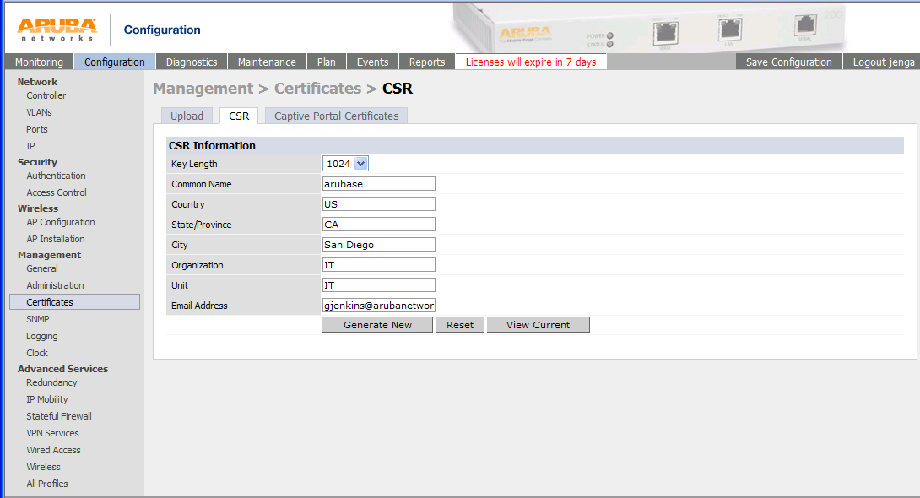
    - Copy entire request from “-----BEGIN….” to “…REQUEST-----“
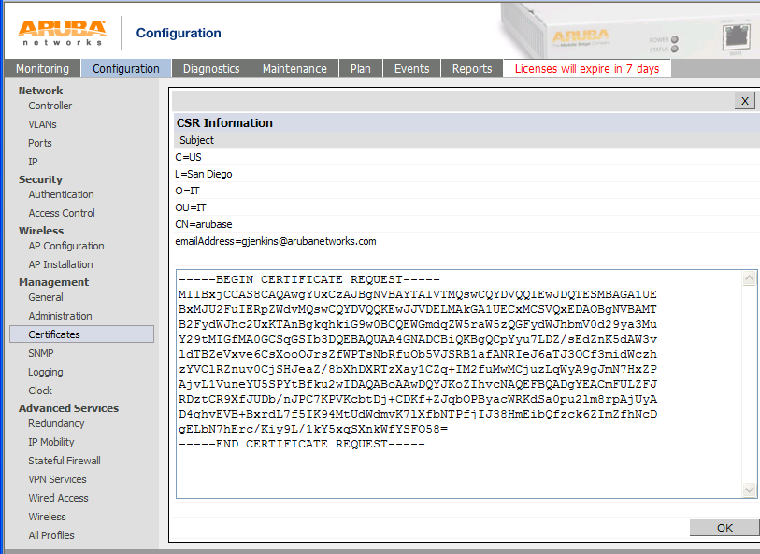

    - Using your web browser go to your MS Certificate Server with the url of http://x.x.x.x/certsrv
    - > Request a certificate
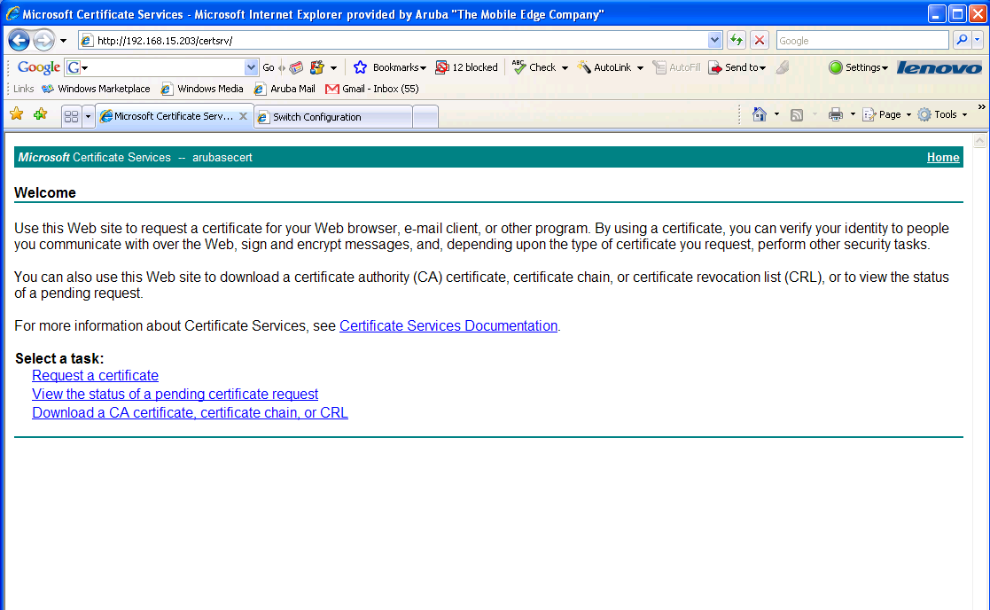

    - Submit a certificate request by using a base-64-encoded….
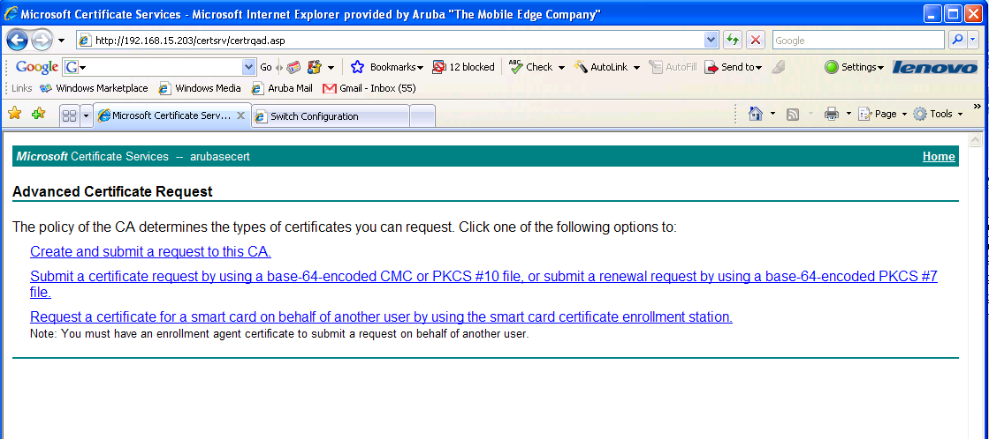

    - Paste in CSR information
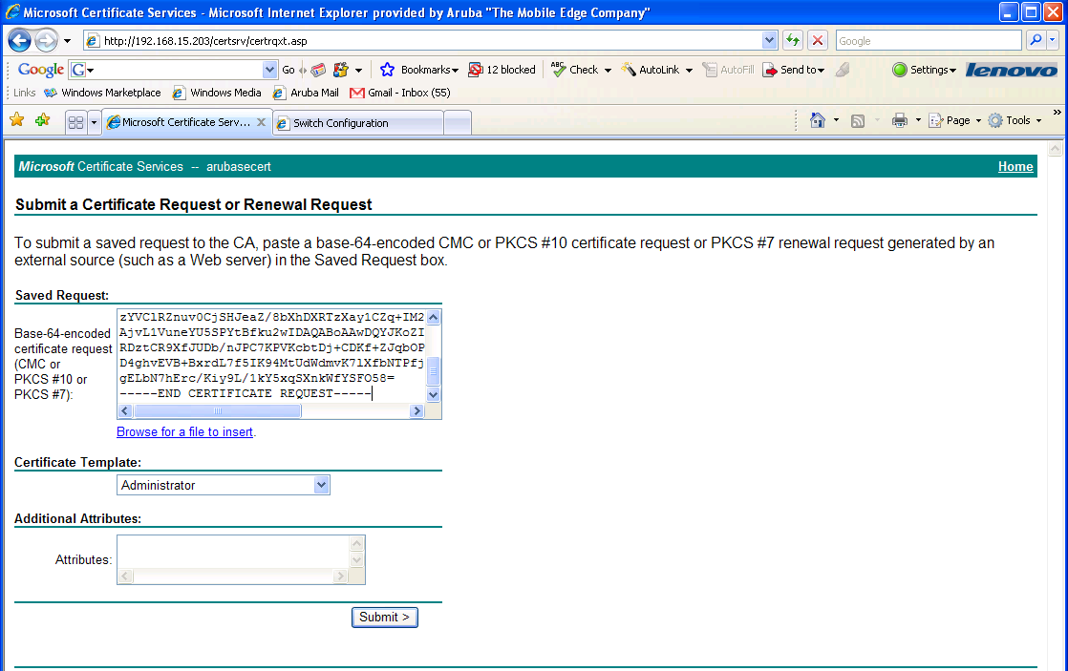

    - The Cert Admin will need to approve the pending request via the MS Cert Authority. You do this by right clicking on it and choosing Issue
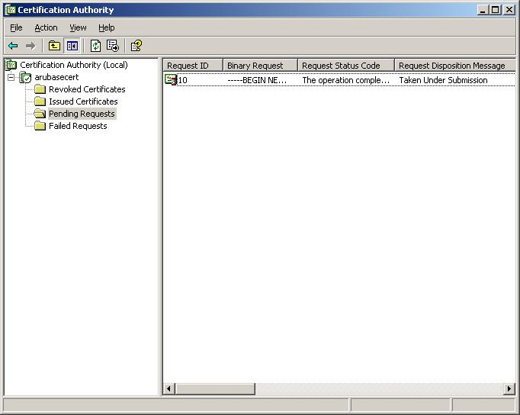

    - You will now be able to web surf back to http://x.x.x.x/certsrv and download your cert. You should use a name that tells you it is the Server Cert so you don’t get it mixed up with your CA Cert
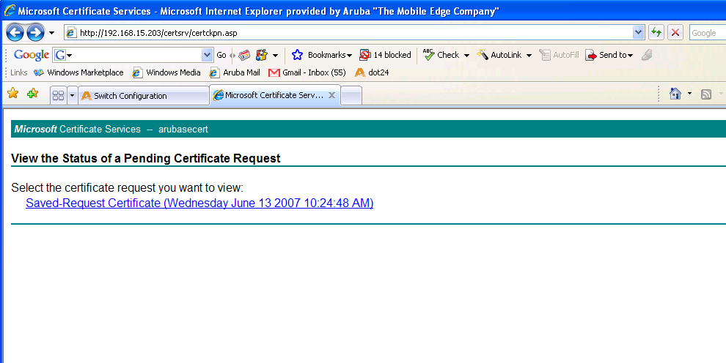
    - Upload the Server Cert to the Aruba Controller.
      - Cert format is PEM
      - Cert Type is Server Cert
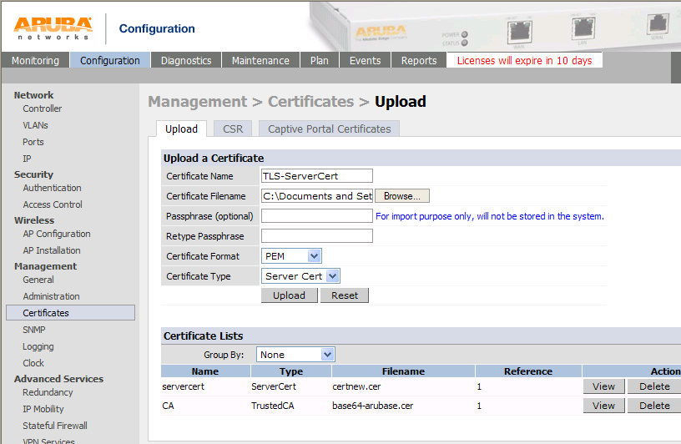

  - Trusted CA Cert
    - From the Windows 2003 server go to Start> run and type mmc into the run dialog box. This will bring up the mmc console.
    - go to File > add snap-in
    - Add the Certificate snap-in with Computer account
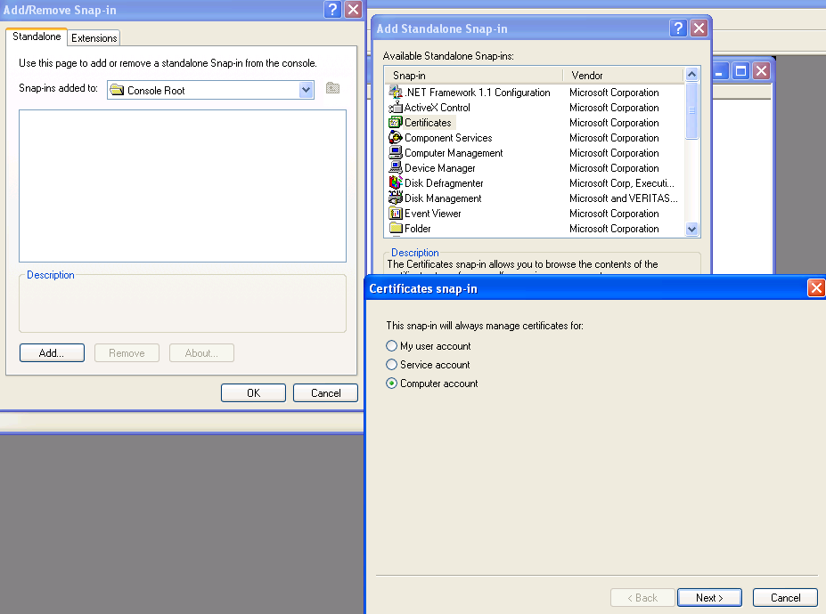

    - Under the Trusted Root Cert Auth. find your Cert. This was created during the install of the MS Cert Server.
    - Right click on it to export it
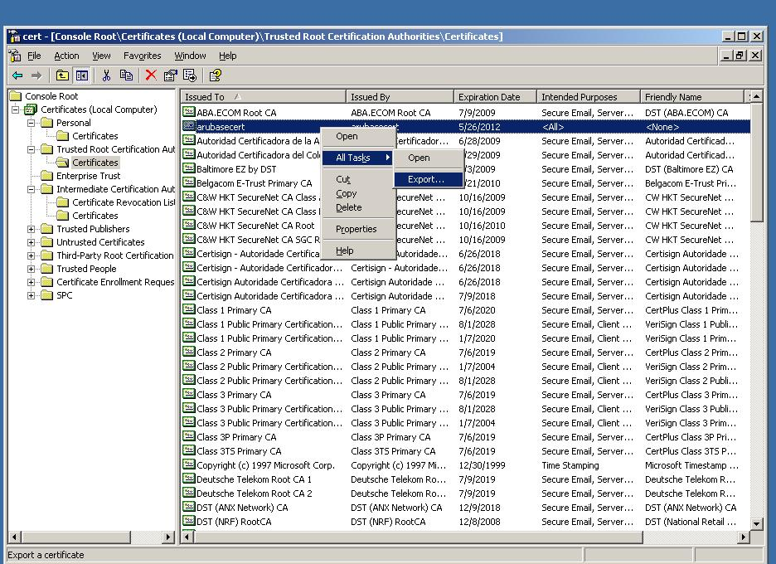

    - Export without the private key
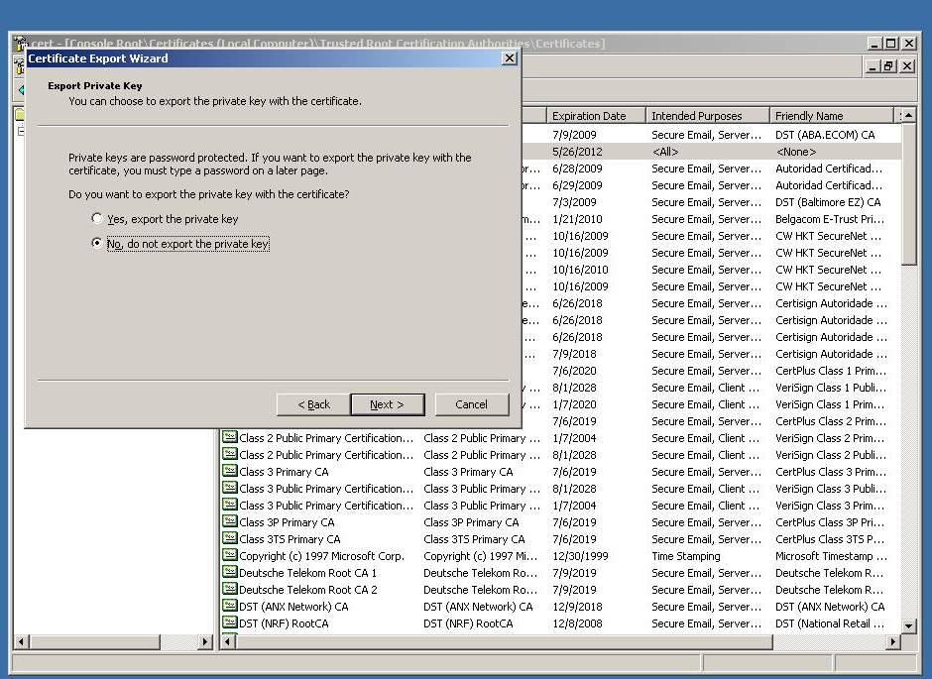
    - Base-64 encoded X.509 format. Again name it with a name so that you know it is the CA Cert.
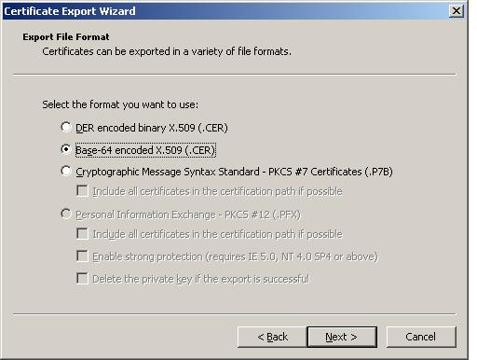
    - Upload the TrustedCA to the Aruba Controller.
      - Cert format is PEM
      - Cert Type is Trusted CA
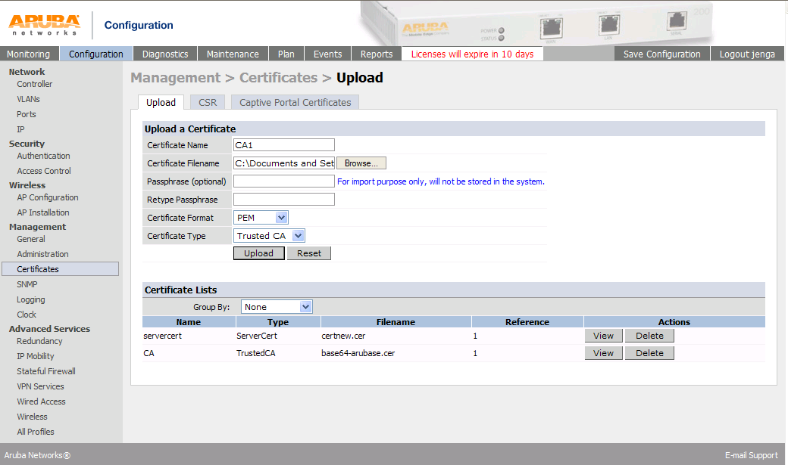

- Controller Authentication Configuration
  - Configure TLS AAA Profile
    - Go to Configuration > Security > Authentication > Profiles
    - Click on add at the bottom and create a new AAA Profile
    - Chose the Initial and Default role you want to use
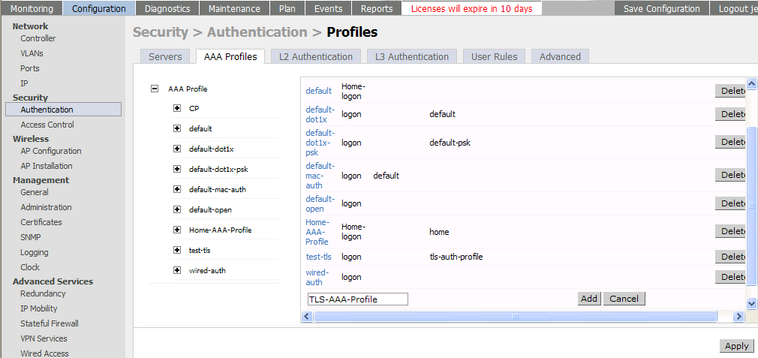

  - 802.1X Authentication Profile
    - Create a new 802.1x auth profile
    - Enable Termination
    - EAP-Type – eap-tls
    - Inner EAP-Type – eap-tls
    - Make sure you Apply before the next step
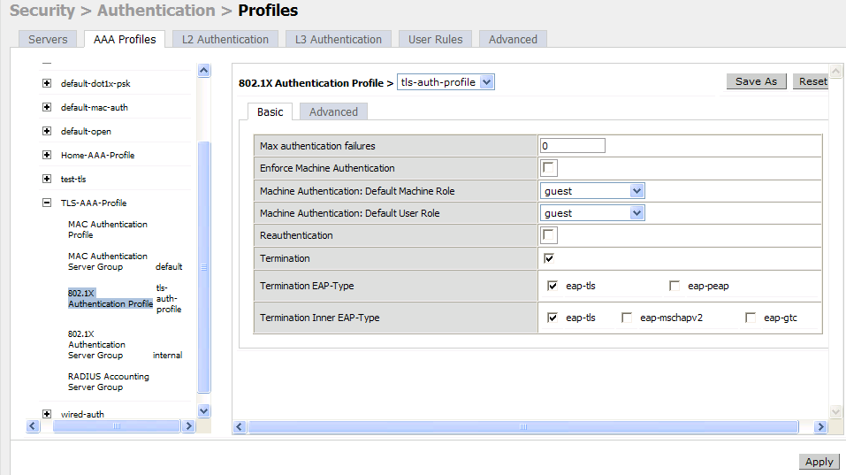
    - Go into the Advanced tab
    - Select your CA Cert and your Server Cert
    - If you want a cert based login you will need select TLS Guest Access and a TLS Guest Role. If you do not select this option you will need to tie in some type of Auth Server
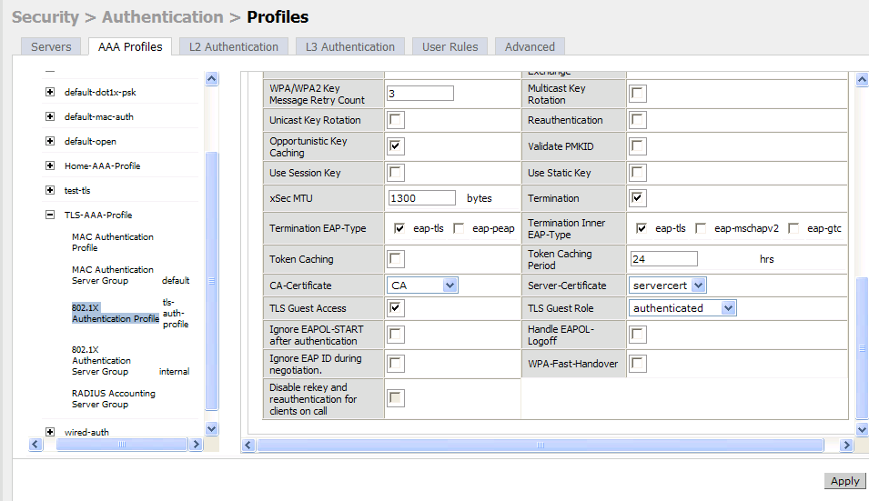

  - 802.1X Authentication Server Group
    - Select the internal server as the Auth Server Group. I don’t understand why this is required for Guest TLS but it is. You do not need any usernames or passwords for Guest TLS.
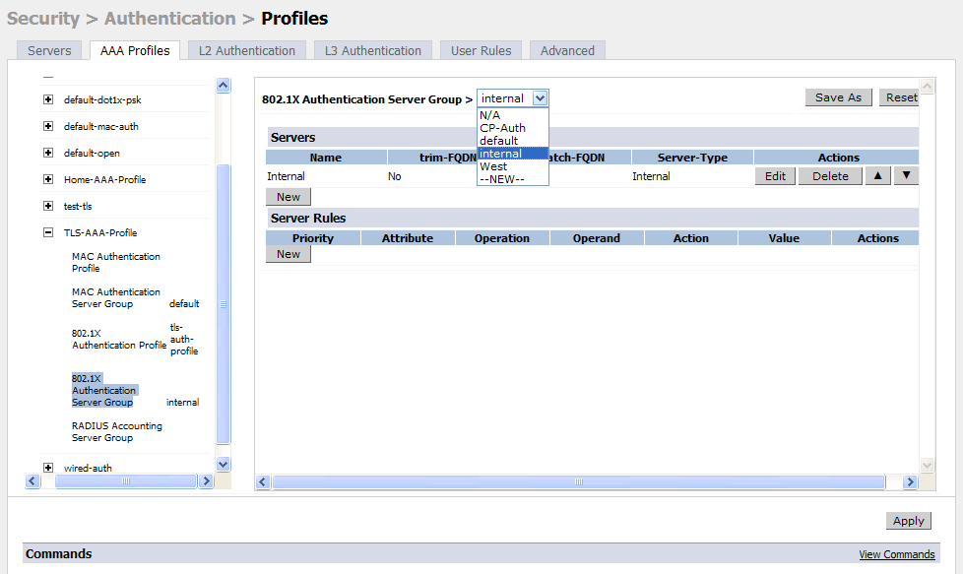

- AP Configuration
  - Add TLS Virtual AP
  - under Configuration > AP Group > - add a SSID
  - From the AAA Profile drop down menu select the TLS profile and apply
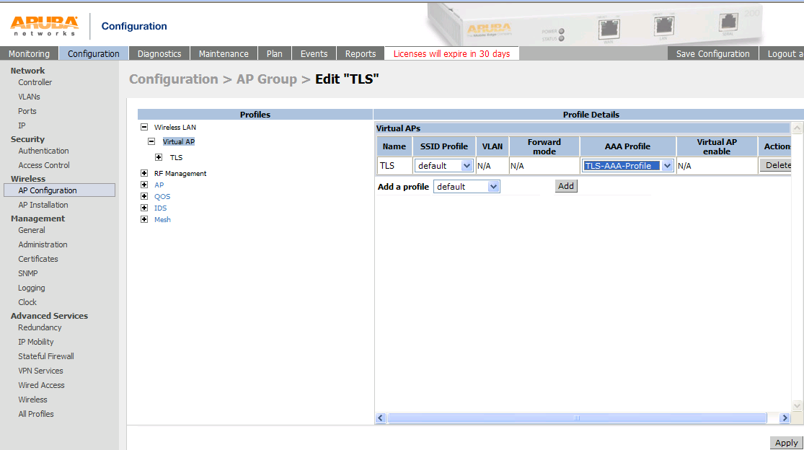

  - Go into the new virtual AP and edit the SSID profile
  - Add a SSID name
  - Select WPA and TKIP or WPA2 and AES
  - Click on save as at the top right and give it a name.
  - Apply
Note: do not edit the default

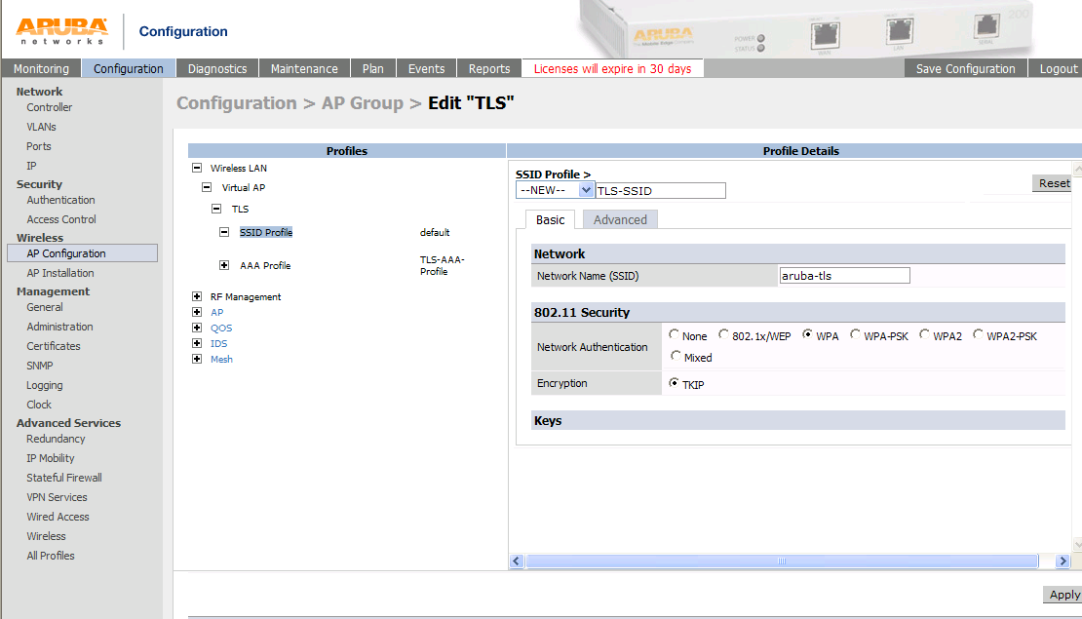

- Client Configuration
  - From you client web surf to your cert server http://x.x.x.x/certsrv
  - Click on Request a certificate
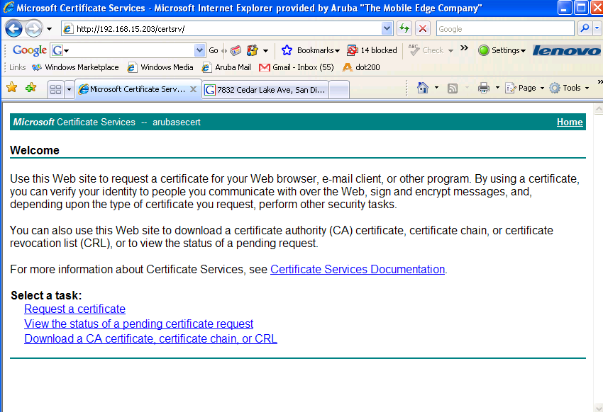

  - Select Web Browser Certificate
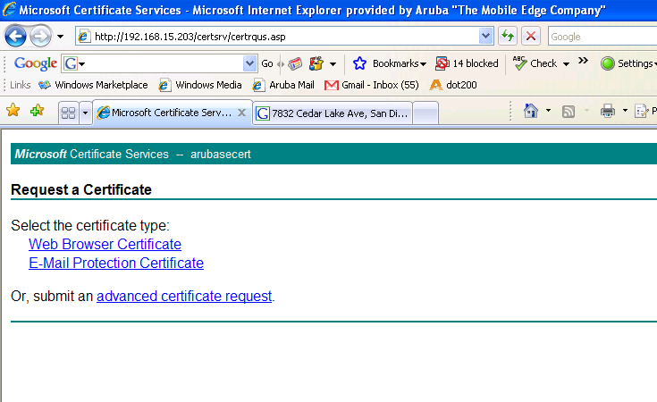

  - Fill in form
  - Submit
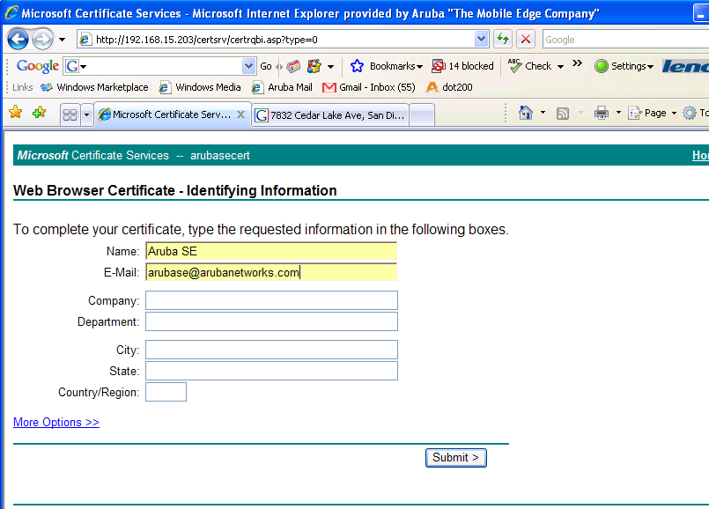

- The Cert Admin will need to approve the pending request via the MS Cert Authority. You do this by right clicking on it and choosing Issue

- You will now be able to web surf back to http://x.x.x.x/certsrv and install your cert.

