For Tacacs+ configuration on Nortel switch followed below configuration command
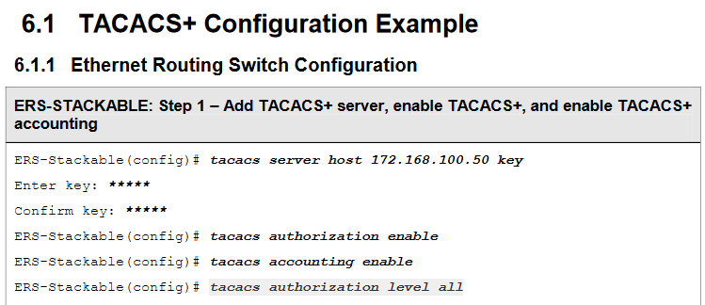
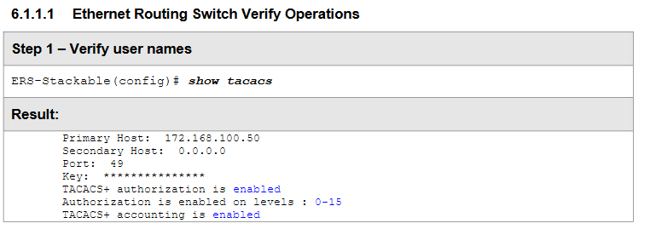
Clearpass Enforcement profile for Read write access
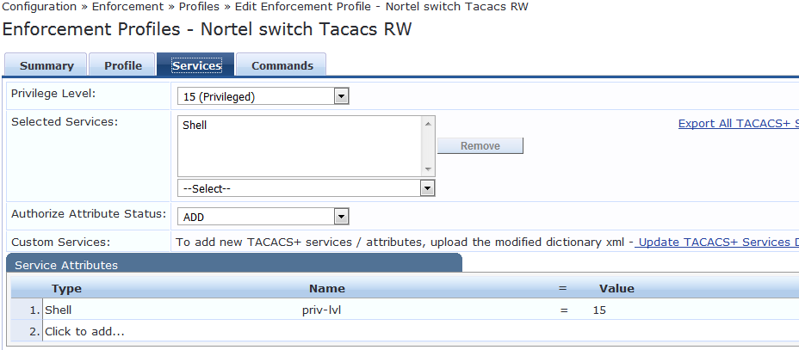

Enforcement policies
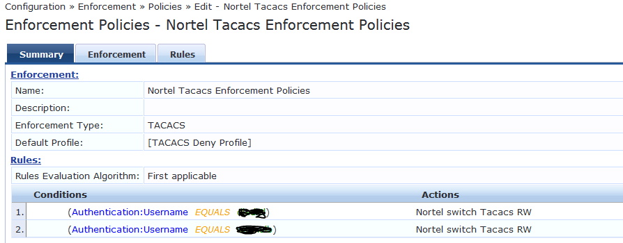

If we insert “Tacacs authorization level all” this command on switch, below are the detail accounting log on CPPM
But same time I got “your command was not authorized” this message on Nortel switch while entering any command.
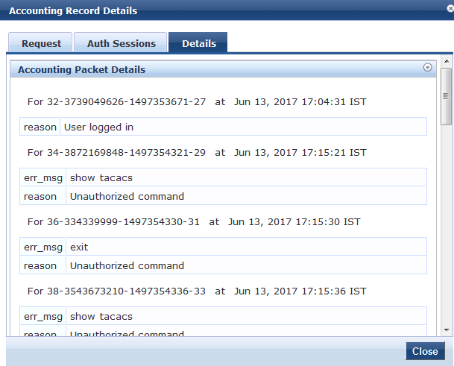

If we removed “Tacacs authorization level all” this command on switch, below are the detail accounting log on CPPM (Missing commands output in accounting)
All users are able to access all commands on Nortel switch.
