- (IT.WAC.ARB650.AYZ-ARB1) #show version
ArubaOS (MODEL: Aruba650), Version 6.4.2.5

- SSID Name : LigTV-ARGE
- Radius1 : 10.10.10.252,Radius2 : 10.10.10.251
- Controller IP : 10.10.10.250

802.1X AND MAC FILTERING STEPS

- Radius server defined, under Servers. Under Radius servers group and instance referenced as below
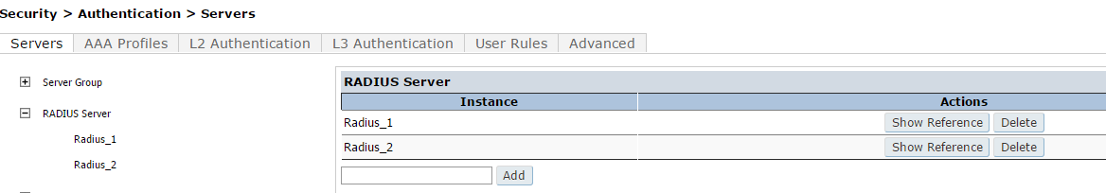

- AAA Profiles

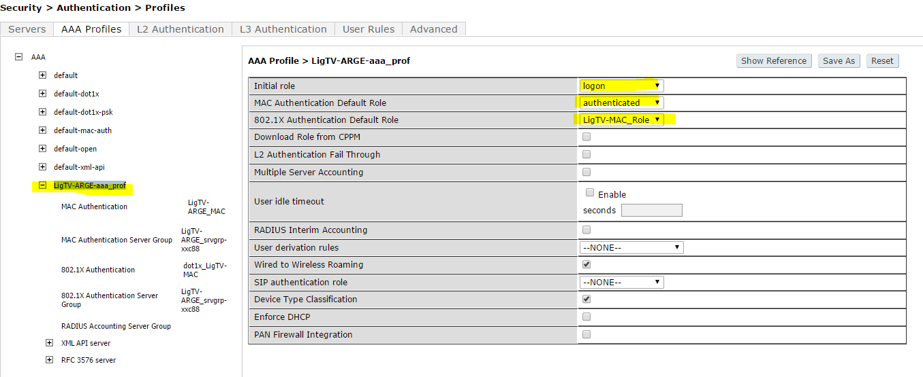

- Mac Authentication Profile
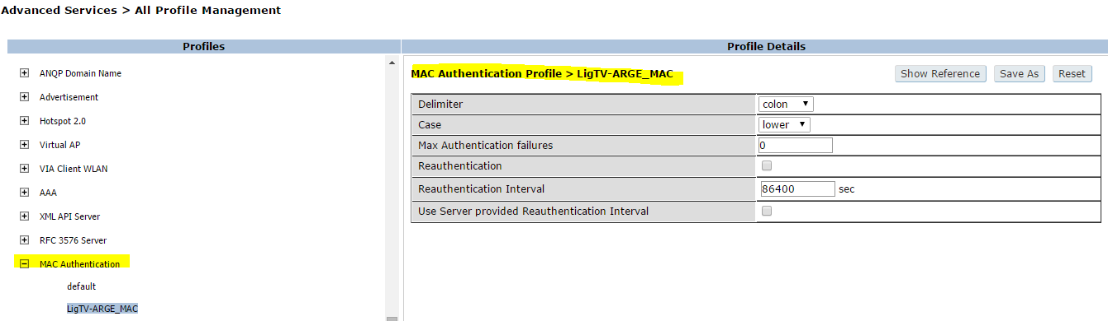
- 802.1x Authentication Profile
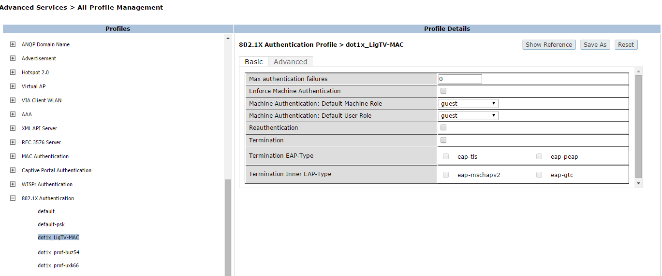

5- Server Group
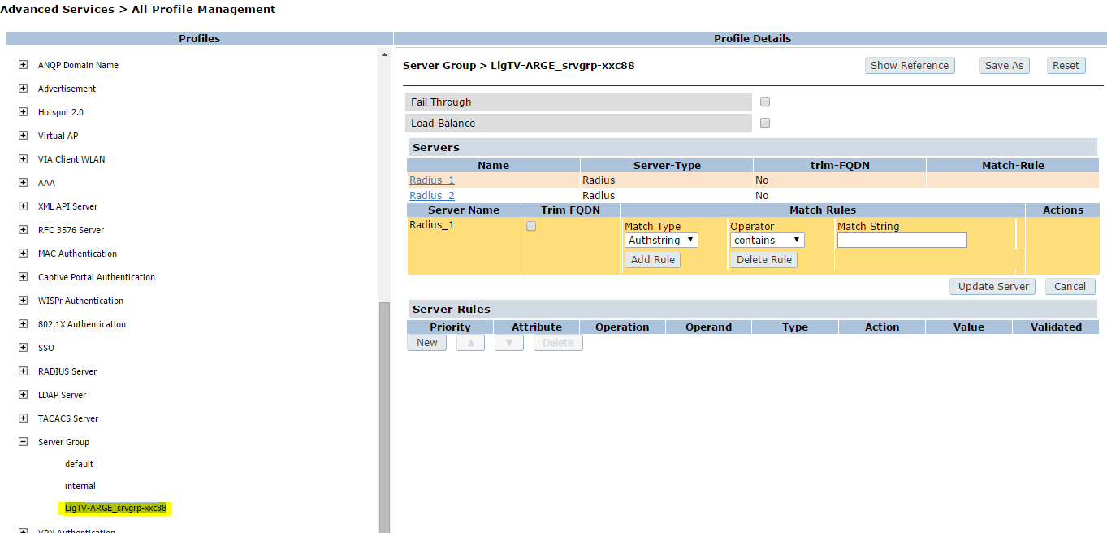

- SSID Profile
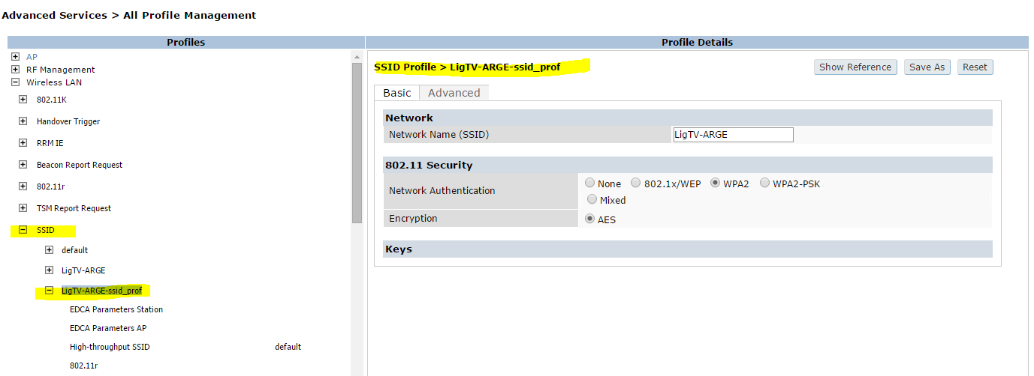

- User defined under Internal DB
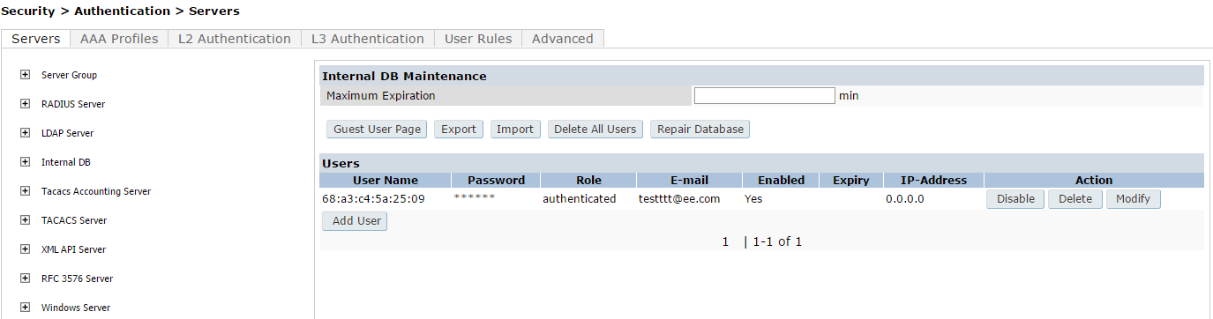

- User logs
(IT.WAC.ARB650.AYZ-ARB1) #show log all | include 68:a3:c4:5a:25:09

ug 21 09:01:29 webui[1522]: USER:admin@10.10.10.10COMMAND:<local-userdb add username " 68:a3:c4:5a:25:09" password ****** role "authenticated" email "testttt@ee.com" > -- command executed successfully
Aug 21 09:01:31 authmgr[2344]: <522275> <ERRS> |authmgr| User Authentication failed. username=68:a3:c4:5a:25:09 userip=0.0.0.0 usermac=68:a3:c4:5a:25:09 servername=Internal serverip=10.10.10.250apname=LigTV-Ofis bssid=00:24:6c:07:5d:11
Aug 21 09:02:09 authmgr[2344]: <522275> <ERRS> |authmgr| User Authentication failed. username=68:a3:c4:5a:25:09 userip=0.0.0.0 usermac=68:a3:c4:5a:25:09 servername=Internal serverip=10.10.10.250apname=LigTV-Toplanti bssid=d8:c7:c8:a7:af:01
Aug 21 12:56:52 authmgr[2344]: <522275> <ERRS> |authmgr| User Authentication failed. username=68:a3:c4:5a:25:09 userip=0.0.0.0 usermac=68:a3:c4:5a:25:09 servername=Internal serverip=10.10.10.250apname=LigTV-Toplanti bssid=d8:c7:c8:a7:af:01
Aug 21 12:57:30 authmgr[2344]: <522275> <ERRS> |authmgr| User Authentication failed. username=68:a3:c4:5a:25:09 userip=0.0.0.0 usermac=68:a3:c4:5a:25:09 servername=Internal serverip=10.10.10.250apname=LigTV-Toplanti bssid=d8:c7:c8:a7:af:01
Aug 21 13:29:53 authmgr[2344]: <520002> <ERRS> |authmgr| Authentication server request Timeout, username=host/LTOCANNB.COMPANY.LOCAL userip=0.0.0.0 usermac=68:a3:c4:5a:25:09 servername= Radius_1 serverip= 10.10.10.252bssid=d8:c7:c8:a7:af:01 apname=LigTV-Toplanti
Aug 21 13:29:58 authmgr[2344]: <520002> <ERRS> |authmgr| Authentication server request Timeout, username=host/LTOCANNB.COMPANY.LOCAL userip=0.0.0.0 usermac=68:a3:c4:5a:25:09 servername= Radius_1 serverip= 10.10.10.252bssid=d8:c7:c8:a7:af:01 apname=LigTV-Toplanti
Aug 21 13:30:03 authmgr[2344]: <520002> <ERRS> |authmgr| Authentication server request Timeout, username=host/LTOCANNB.COMPANY.LOCAL userip=0.0.0.0 usermac=68:a3:c4:5a:25:09 servername= Radius_1 serverip= 10.10.10.252bssid=d8:c7:c8:a7:af:01 apname=LigTV-Toplanti
Aug 21 13:30:06 authmgr[2344]: <520002> <ERRS> |authmgr| Authentication server request Timeout, username=DIGITURK\dtuakbulut userip=0.0.0.0 usermac=68:a3:c4:5a:25:09 servername= Radius_1 serverip= 10.10.10.252bssid=d8:c7:c8:a7:af:01 apname=LigTV-Toplanti
Aug 21 13:30:08 authmgr[2344]: <520002> <ERRS> |authmgr| Authentication server request Timeout, username=host/LTOCANNB.COMPANY.LOCAL userip=0.0.0.0 usermac=68:a3:c4:5a:25:09 servername= Radius_1 serverip= 10.10.10.252bssid=d8:c7:c8:a7:af:01 apname=LigTV-Toplanti
Aug 21 13:30:08 authmgr[2344]: <522276> <ERRS> |authmgr| Authentication Server Out Of Service while serving request. servername=Radius_1 serverip=10.10.10.252 username=host/LTOCANNB.COMPANY.LOCAL userip=0.0.0.0 usermac=68:a3:c4:5a:25:09 bssid=d8:c7:c8:a7:af:01 apname=LigTV-Toplanti
Aug 21 13:30:11 authmgr[2344]: <520002> <ERRS> |authmgr| Authentication server request Timeout, username=DIGITURK\dtuakbulut userip=0.0.0.0 usermac=68:a3:c4:5a:25:09 servername= Radius_1 serverip= 10.10.10.252bssid=d8:c7:c8:a7:af:01 apname=LigTV-Toplanti
Aug 21 13:30:18 authmgr[2344]: <520002> <ERRS> |authmgr| Authentication server request Timeout, username=host/LTOCANNB.COMPANY.LOCAL userip=0.0.0.0 usermac=68:a3:c4:5a:25:09 servername= Radius_2 serverip= 10.10.10.251bssid=d8:c7:c8:a7:af:01 apname=LigTV-Toplanti
Aug 21 13:30:21 authmgr[2344]: <520002> <ERRS> |authmgr| Authentication server request Timeout, username=DIGITURK\dtuakbulut userip=0.0.0.0 usermac=68:a3:c4:5a:25:09 servername= Radius_1 serverip= 10.10.10.252bssid=d8:c7:c8:a7:af:01 apname=LigTV-Toplanti
Aug 21 13:30:21 authmgr[2344]: <522276> <ERRS> |authmgr| Authentication Server Out Of Service while serving request. servername=Radius_1 serverip=10.10.10.252 username=DIGITURK\dtuakbulut userip=0.0.0.0 usermac=68:a3:c4:5a:25:09 bssid=d8:c7:c8:a7:af:01 apname=LigTV-Toplanti
Aug 21 13:30:23 authmgr[2344]: <520002> <ERRS> |authmgr| Authentication server request Timeout, username=host/LTOCANNB.COMPANY.LOCAL userip=0.0.0.0 usermac=68:a3:c4:5a:25:09 servername= Radius_2 serverip= 10.10.10.251bssid=d8:c7:c8:a7:af:01 apname=LigTV-Toplanti
Aug 21 13:30:28 authmgr[2344]: <520002> <ERRS> |authmgr| Authentication server request Timeout, username=host/LTOCANNB.COMPANY.LOCAL userip=0.0.0.0 usermac=68:a3:c4:5a:25:09 servername= Radius_2 serverip= 10.10.10.251bssid=d8:c7:c8:a7:af:01 apname=N/A
Aug 21 13:30:33 authmgr[2344]: <522276> <ERRS> |authmgr| Authentication Server Out Of Service while serving request. servername=Radius_2 serverip=10.10.10.251 username=host/LTOCANNB.COMPANY.LOCAL userip=0.0.0.0 usermac=68:a3:c4:5a:25:09 bssid=d8:c7:c8:a7:af:01 apname=N/A
Aug 21 13:30:40 authmgr[2344]: <520002> <ERRS> |authmgr| Authentication server request Timeout, username=host/LTOCANNB.COMPANY.LOCAL userip=0.0.0.0 usermac=68:a3:c4:5a:25:09 servername= Radius_1 serverip= 10.10.10.252bssid=d8:c7:c8:a7:af:01 apname=LigTV-Toplanti
Aug 21 13:30:45 authmgr[2344]: <520002> <ERRS> |authmgr| Authentication server request Timeout, username=host/LTOCANNB.COMPANY.LOCAL userip=0.0.0.0 usermac=68:a3:c4:5a:25:09 servername= Radius_1 serverip= 10.10.10.252bssid=d8:c7:c8:a7:af:01 apname=LigTV-Toplanti
Aug 21 13:30:50 authmgr[2344]: <520002> <ERRS> |authmgr| Authentication server request Timeout, username=host/LTOCANNB.COMPANY.LOCAL userip=0.0.0.0 usermac=68:a3:c4:5a:25:09 servername= Radius_1 serverip= 10.10.10.252bssid=d8:c7:c8:a7:af:01 apname=LigTV-Toplanti
Aug 21 13:30:53 authmgr[2344]: <520002> <ERRS> |authmgr| Authentication server request Timeout, username=DIGITURK\dtuakbulut userip=0.0.0.0 usermac=68:a3:c4:5a:25:09 servername= Radius_1 serverip= 10.10.10.252bssid=d8:c7:c8:a7:af:01 apname=LigTV-Toplanti
Aug 21 13:30:55 authmgr[2344]: <520002> <ERRS> |authmgr| Authentication server request Timeout, username=host/LTOCANNB.COMPANY.LOCAL userip=0.0.0.0 usermac=68:a3:c4:5a:25:09 servername= Radius_1 serverip= 10.10.10.252bssid=d8:c7:c8:a7:af:01 apname=LigTV-Toplanti
Aug 21 13:30:55 authmgr[2344]: <522276> <ERRS> |authmgr| Authentication Server Out Of Service while serving request. servername=Radius_1 serverip=10.10.10.252 username=host/LTOCANNB.COMPANY.LOCAL userip=0.0.0.0 usermac=68:a3:c4:5a:25:09 bssid=d8:c7:c8:a7:af:01 apname=LigTV-Toplanti

