ClearPass Web Auth Service:

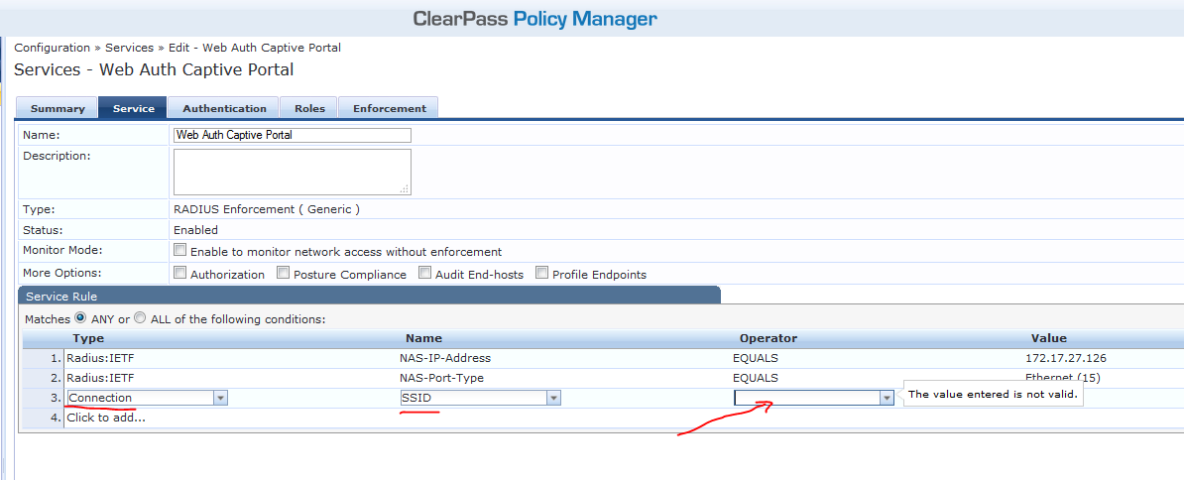

Current Layer 3 Profile On Controller

I’ll change the Login Page to the new Captive Portal Page for clients on the new SSID

