172.16.1.42 Client
192.168.250.50 DNS server

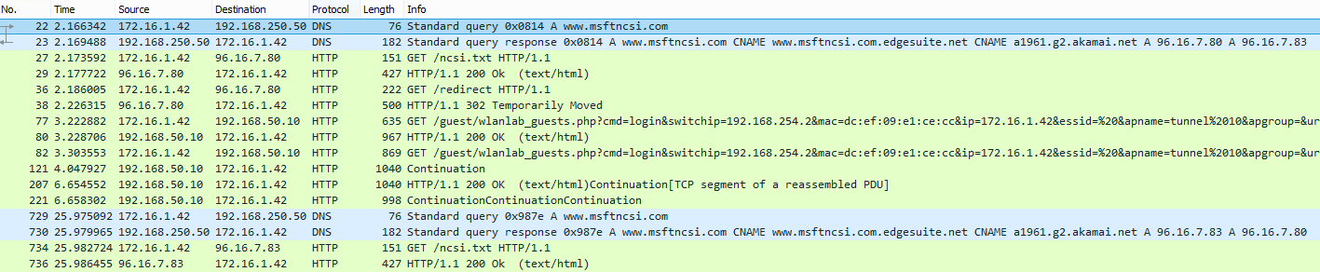

- Client send a query to dns server asking for www.msftncsi.com
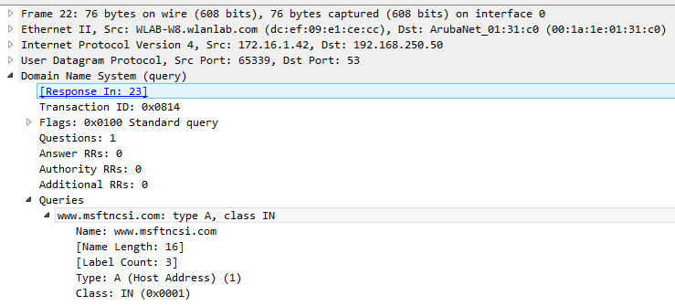
- DNS server replies the query
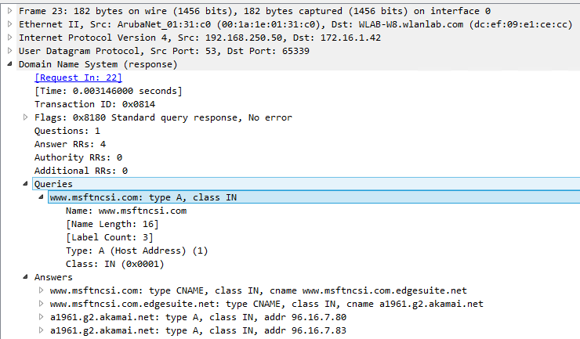
- Computer tries to download ncsi.txt (it is expecting to see Microsoft NCSI inside that txt) from that address but since it has no internet access yet it fails
*** attaching this image to show what the txt file looks like***

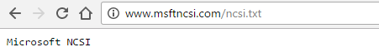
- Computer now tries to go to www.msftncsi.com/redirect
- WLC spoofs the destination IP address and send a http 302 “temporarily moved”
- Guest now knows that it need to go to the captive portal.

