Hi ,
Sir I have 2 MSR 2000 , named MSR1 & MSR2. I mashed both MSRs successfully, I made 3 VLANs on MSR1 : VLAN1(Default), VLAN 20 (get IP from Controller200 FE interface)& VLAN 40 (also get IP from Controller 200 GE Interface).
For MSR2 I also Configured 3 Vlans: Vlan1 (Default), Vlan20(get ip fom Controller’s Interface FE through MSR1 ) & VLAN 40 (get ip fom Controller’s Interface GE through MSR1). But I cant get IP from Controller on MSR2 BSS.
Configurations are given below:
I set Controller’s FE interface on Vlan 20 ip:192.168.20.1 & having Ip Pool 192.168.20.10-192.168.20.20
Controller’s GE interface on VLAN 40 having ip:192.168.40.1 IP pool 192.168.40.10-192.168.40.20
Made 2 BSS and configure VLAN in BSSs options to Access VLAN 20 & 40 simultaneously.
Configuration on MSR1 snapshots are follows:
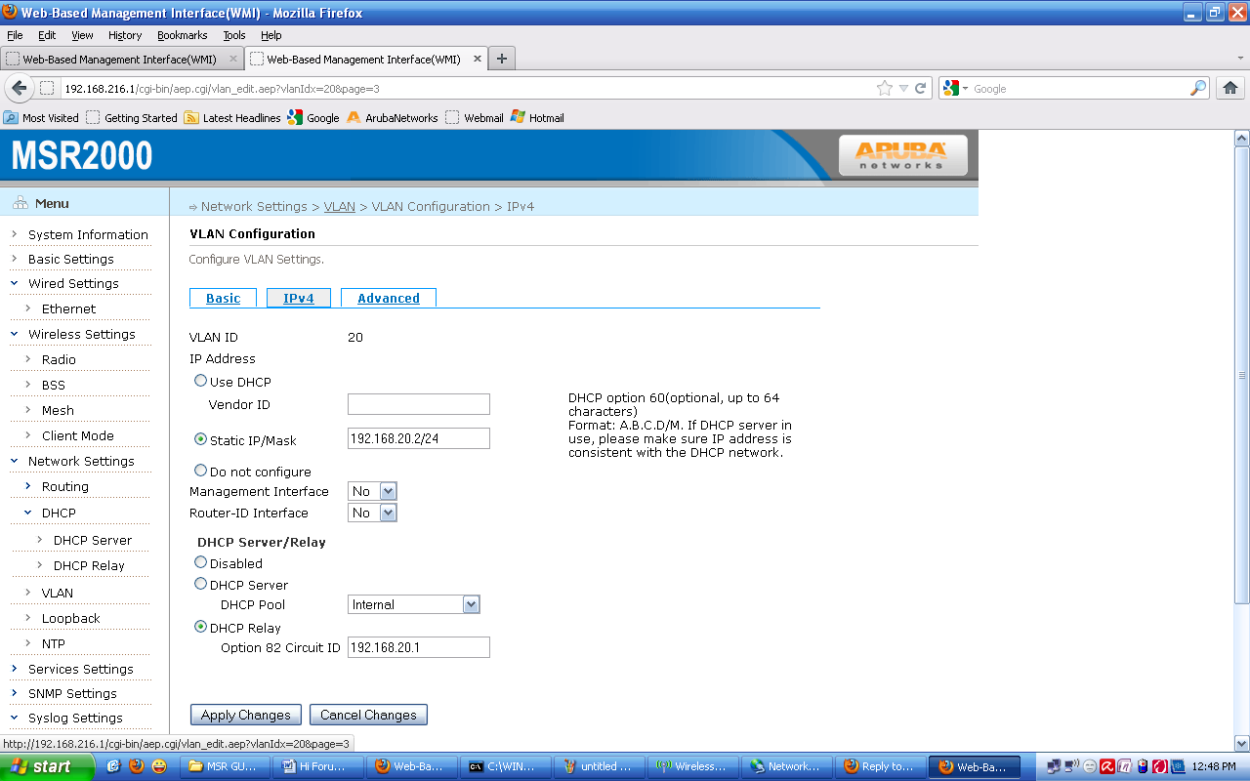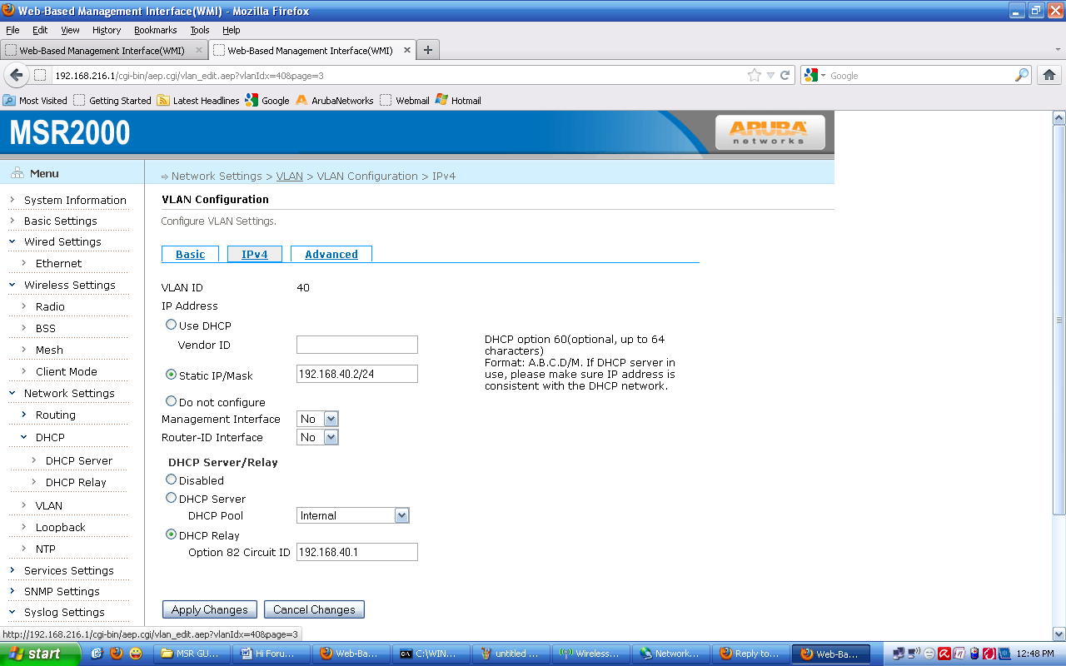
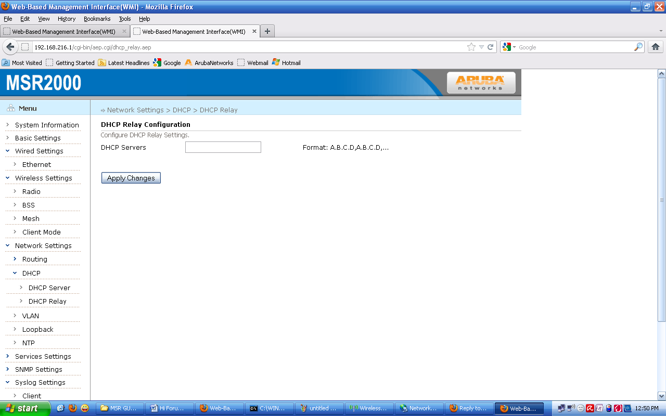

Snapshots of Configuration on MSR2 are following: 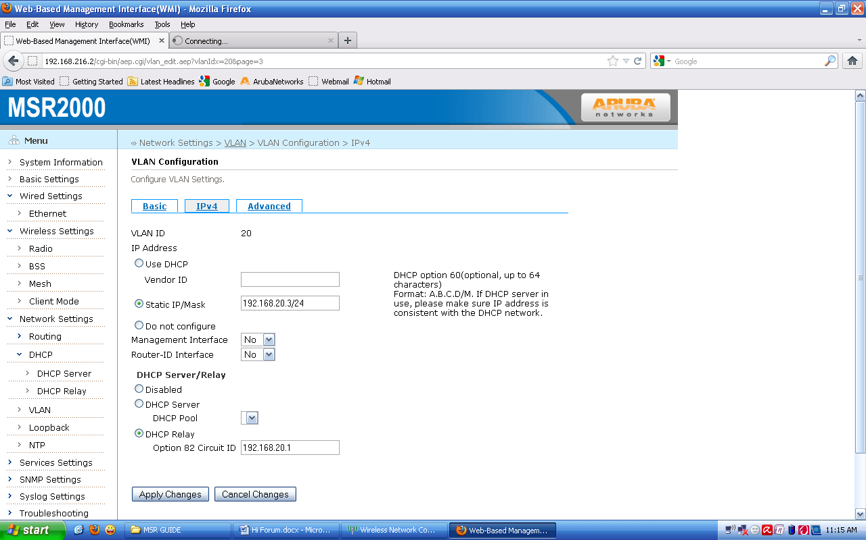
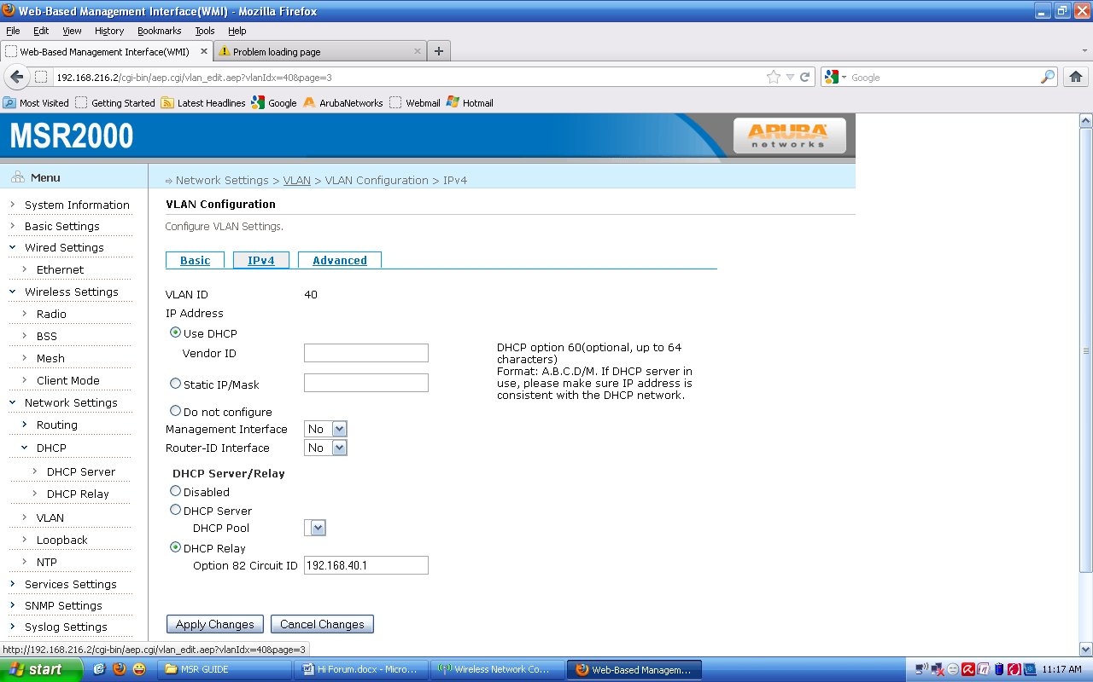
Running Configuration of MSR1
ip nat
ip dhcp relay
ip dhcp server
dns 4.2.2.2
pool Internal
domain-name www.msr.com
gateway 192.168.216.1
network 192.168.216.0/24
pool-dns 4.2.2.2
range 192.168.216.100 192.168.216.200
pool MSR-Internal-Pool
domain-name www.arubanetworks.com
gateway 192.168.2.1
network 192.168.2.0/24
pool-dns 4.2.2.2
range 192.168.2.100 192.168.2.200
pool FaIz
gateway 192.168.1.1
network 192.168.1.0/24
pool-dns 4.2.2.2
range 192.168.1.100 192.168.1.120
location-info
mesh
neighbor-list
authentication open key-management wpa
psk ascii ZHTDemoMesh
mesh-id ZHTDemoMesh
neighbor-list-type inactive
preferred-link 1
neighbor host MSR2K-Node2
preferred channel 165
preferred radio 1
router awr
debug error
enable
router multicast
debug state
disable
router ospf
debug none
enable
redistribute awr
service avt
mode disabled
service ntp
disable
service recovery
debug-level error
enable
service rf-management
debug process
service roaming-motrix
debug-level dump
disable
service vplm
allowed-vlan auto
enable
country-code US
hostname MSR2K-1-Portal
interface dot11radio 0
antenna-gain 5
beacon-interval 100
bss 15
access-list
ssid ZHTDemo
switchport access vlan 1
wmm
bss 2
access-list
access-category be
multicast-optimization
multicast-rate 11
ssid MSR1-Demo
switchport access vlan 2
wmm
bss 14
access-list
access-category be
ssid ZHT-20
switchport access vlan 20
wmm
bss 1
access-list
ssid ZHT-40
switchport access vlan 40
wmm
bss 6
access-list
access-category be
multicast-optimization
multicast-rate 11
ssid Faiz
switchport access vlan 5
wmm
bss 10
access-list
access-category be
multicast-optimization
multicast-rate 11
ssid Faisal
switchport access vlan 100
wmm
channel-list bg 1,6,11
cts-protection disable
txpower 23
wireless-mode ng
interface dot11radio 1
antenna-gain 5
beacon-interval 100
cts-protection disable
txpower 24
wds auto
max-auto-wds 2
wireless-mode na
interface gigabit-ethernet 0
mode gateway
switchport trunk allowed-vlan 1-2,20,40
switchport site-id 1
interface loopback 0
ip address from-mac
router-id
interface vlan 1
dhcp server Internal
ip address 192.168.216.1/24
management
mtu 1500
interface vlan 2
description MSR1-Demo-VLAN
dhcp server MSR-Internal-Pool
ip address 192.168.2.10/24
mtu 1500
interface vlan 5
dhcp server FaIz
ip address 192.168.1.11/24
mtu 1500
interface vlan 20
dhcp relay option circuit-id 192.168.20.1
ip address 192.168.20.2/24
mtu 1500
interface vlan 40
dhcp relay option circuit-id 192.168.40.1
ip address 192.168.40.2/24
mtu 1500
interface vlan 100
ip address 192.168.100.1/24
mtu 1500
ip telnet server
local-ip 192.168.11.1/24
mesh installation outdoor
snmp-server syscontact support@arubanetworks.com
snmp-server syslocation BeiJing
snmp-server community public ro
snmp-server community private rw
snmp-server trap open client_online
snmp-server trap open client_offline

Running Config on MSR2
ip nat
ip dhcp relay
dhcp-servers 192.168.216.1
ip dhcp server
location-info
mesh
neighbor-list
authentication open key-management wpa
psk ascii ZHTDemoMesh
mesh-id ZHTDemoMesh
neighbor-list-type inactive
preferred-link 1
neighbor host MSR2K-1-Portal
preferred channel 165
preferred radio 1
router awr
debug error
enable
router multicast
debug state
disable
router ospf
debug none
disable
service avt
mode disabled
service ntp
disable
service recovery
debug-level error
enable
service rf-management
debug process
service roaming-motrix
debug-level dump
disable
service vplm
allowed-vlan auto
enable
stp-compatible
country-code US
hostname MSR2K-Node2
interface dot11radio 0
antenna-gain 5
beacon-interval 100
bss 15
access-list
ssid ArubaDemo2
switchport access vlan 1
wmm
bss 2
access-list
access-category be
description Configure on MSR1
multicast-optimization
multicast-rate 11
ssid MSR2-Demo
switchport access vlan 5
wmm
bss 14
access-list
ssid ZHT-20-N2
switchport access vlan 20
wmm
bss 1
access-list
ssid ZHT-40-N2
switchport access vlan 40
wmm
bss 10
access-list
ssid Faisal-2
switchport access vlan 100
wmm
channel-list bg 1,6,11
cts-protection disable
txpower 23
wireless-mode ng
interface dot11radio 1
antenna-gain 5
beacon-interval 100
cts-protection disable
txpower 24
wds auto
max-auto-wds 2
wireless-mode na
interface gigabit-ethernet 0
mode none
switchport trunk allowed-vlan 1-2,20,40
switchport site-id 1
interface loopback 0
interface vlan 1
dhcp relay option circuit-id 192.168.216.1/24
ip address 192.168.216.2/24
management
mtu 1500
interface vlan 5
dhcp relay option circuit-id 192.168.1.11
ip address 192.168.1.12/24
mtu 1500
interface vlan 20
dhcp relay option circuit-id 192.168.20.1
ip address 192.168.20.3/24
mtu 1500
interface vlan 40
dhcp relay option circuit-id 192.168.40.1
ip address dhcp
mtu 1500
interface vlan 100
dhcp relay option circuit-id 192.168.216.1
ip address dhcp
mtu 1500
ip telnet server
mesh installation outdoor
snmp-server syscontact support@arubanetworks.com
snmp-server syslocation BeiJing
snmp-server community public ro
snmp-server community private rw
snmp-server trap open client_online
snmp-server trap open client_offline

