Correctly profiled device
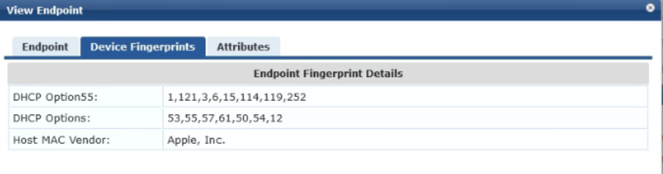
Device with Apple iPhone fingerprint but no host MAC vendor info
