- TLS guest access in 802.1x Auth Profile is disable,
AAA Profile:
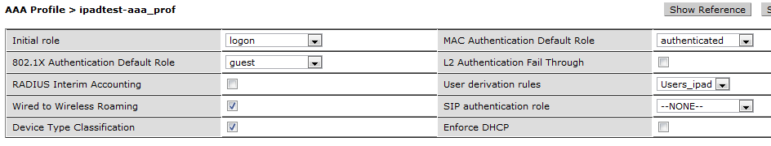
802.1x Auth Profile
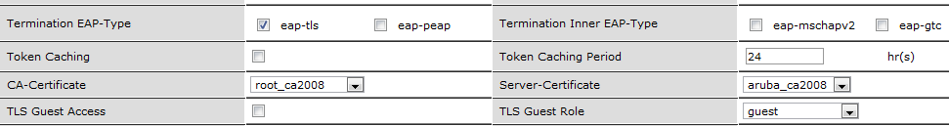
User Rules ( User derivation rule in AAA profile )
IPAD could not connect while config as in above...
Errors in Process logs.
Apr 4 22:11:38 localdb[1636]: <133019> <ERRS> |localdb| User Administrator@testdc.local was not found in the database
Apr 4 22:11:38 localdb[1636]: <133006> <ERRS> |localdb| User Administrator@testdc.local Failed Authentication
Administrator@testdc.local is a username defined in certificate.. Connection succesfull After I added Administrator@testdc.local user to internal database..I think I dont need to add it, If I enable TLS guest acccess.
Internal DB
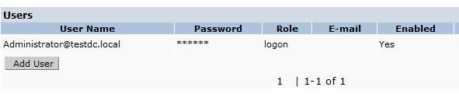
Aruba Assigned user role that defined in 802.1x Authentication Default role to client.So It ignored mac auth default role and User derivaton role
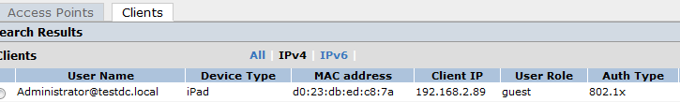
- TLS guest access in 802.1x Auth Profile is enable,
AAA Profile
802.1x Auth Profile
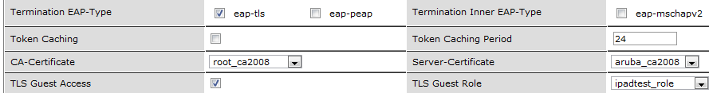
Internal B
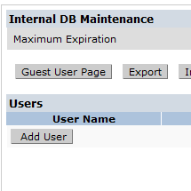
Aruba Assigned user role that defined in TLS Guest Role to client.So It ignored mac auth default role ,User derivaton role, 802.1x Authentication Default .