API Gateway
Aim: Use the swagger UI to get list of groups and create a new group.

Central supports an Application Programming Interface (API) to allow developers to create and manage APIs. It supports polling-based and Representational State Transfer (REST)-based APIs. The REST APIs support HTTP GET operations by providing a specific URL for each query. The output for these operations is returned in the JSON format.

Go to App Selector > Maintenance > API Gateway > Authorized Apps & Tokens > Add Apps & Tokens

Name the application as HOL.

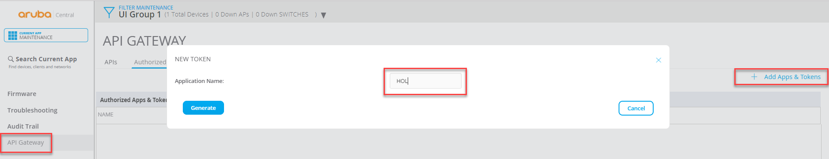
API Gateway Application

An application is generated, named as “HOL”, with client ID, client secret and associated token. These are useful when authenticating an external application.

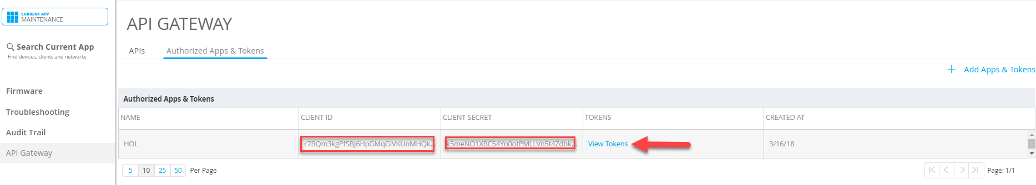
Application Client Details
Click View Tokens

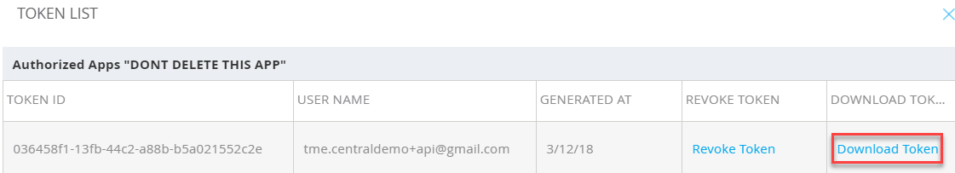
View Token

Click Download Token & another browser window will open up, which provides the access token. Copy access token in a notepad, as it will be used multiple times in swagger tool. Notice that it is valid for only next two hours.

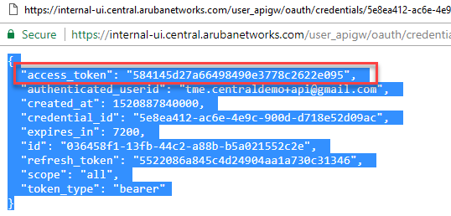

Access Token

Swagger Tool
Central has integrated the swagger tool to help end user to test & familiarize with APIs, without extensive programming knowledge.

Go to API Gateway > APIs > Click Internal API

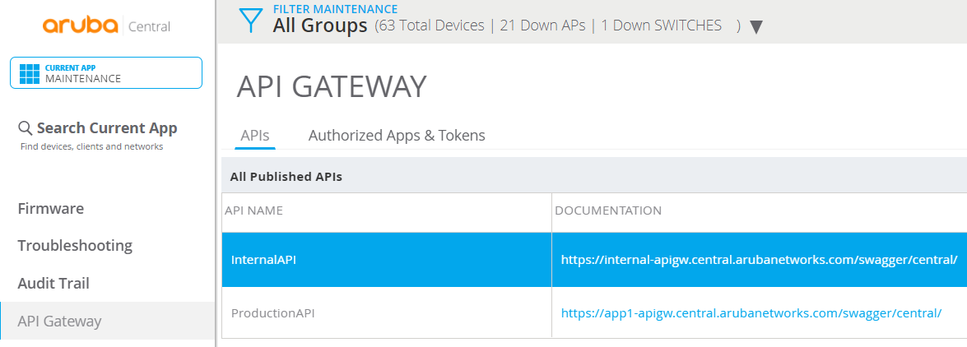
API Gateway

Another tab opens up the swagger tool.

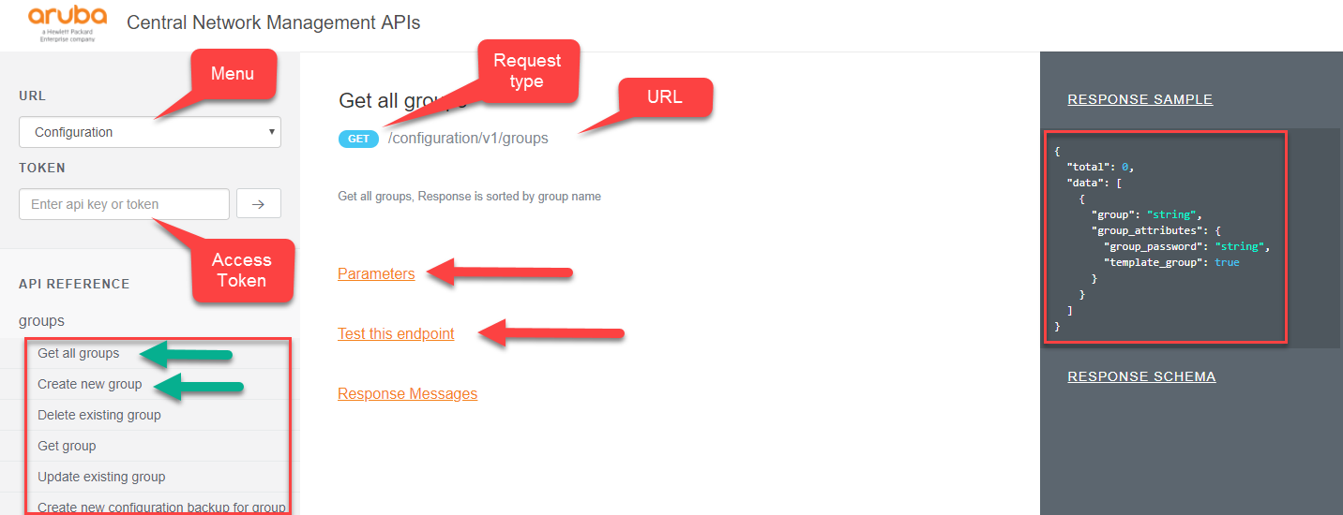
Swagger Tool

Change the URL to Configuration and put it in the access token.

Click on “Get All Groups”.

The middle pane shows the type of request, e.g. GET or POST. The URL contacted and brief description of the API call.

Parameters shows any mandatory or optional information field that have to accompany the API call. Set the offset value to 0.

Click on Test this endpoint > Test.

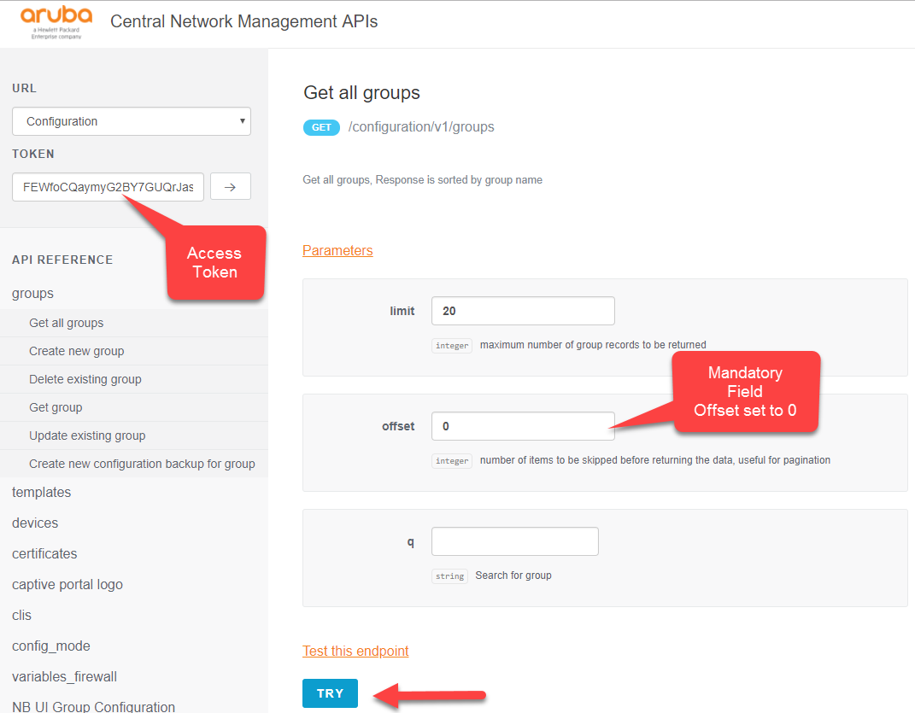
Try API

A window will come up, showing API call results.

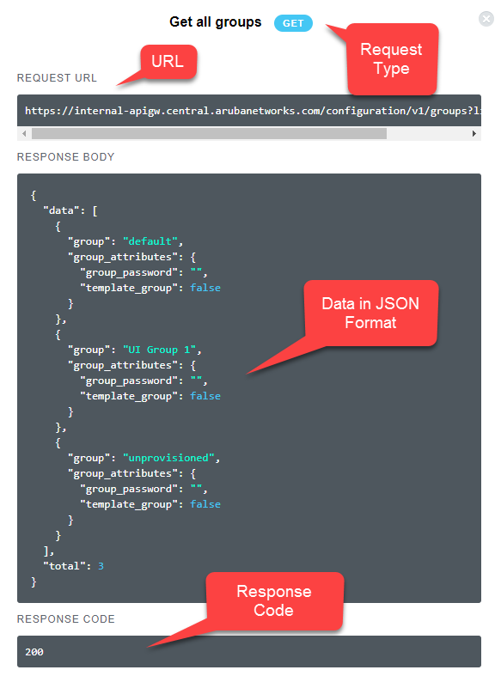
API Call Result

A developer can use this information to create their own applications, authenticate to API GW and make same API calls, as made in swagger, in an HTTPS tunnel. The resulting JSON outputs can be consumed to make intelligent business decisions.

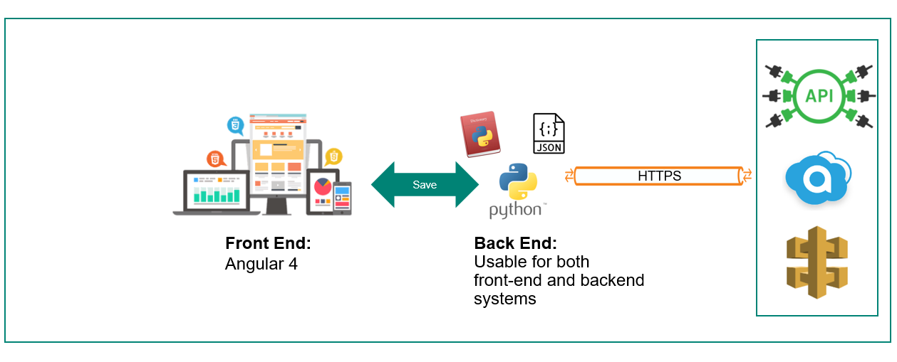
API Based Solution

