Services - AVEVE-Wired-with-healthcheck
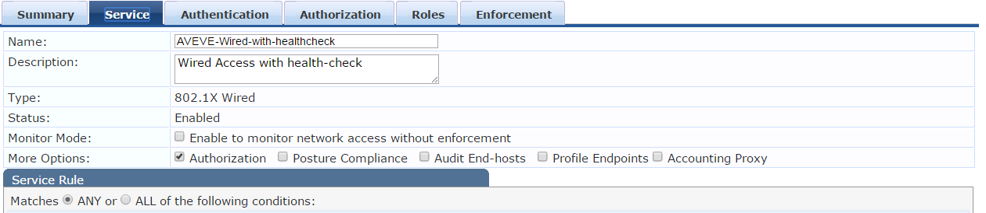
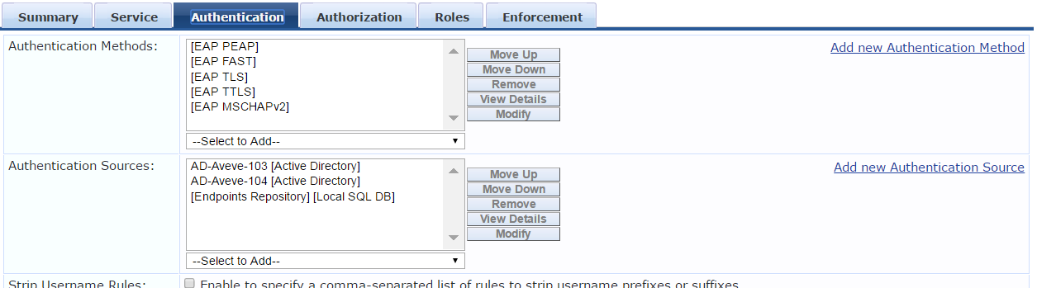
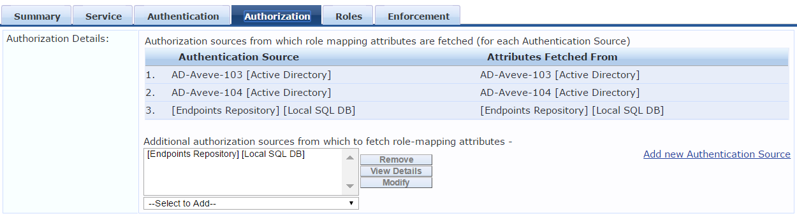
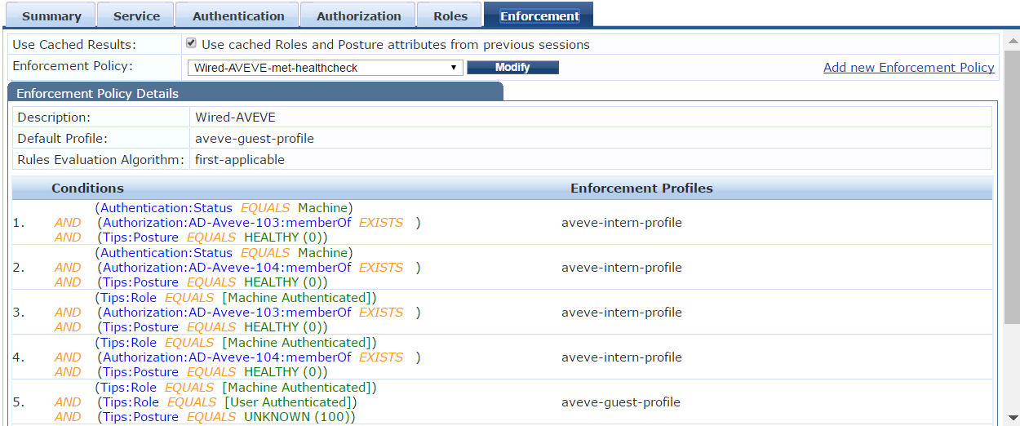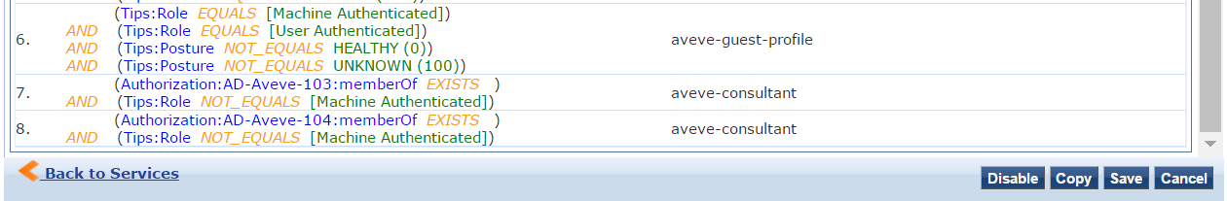
Services - Wired_Health-check-AVEVE
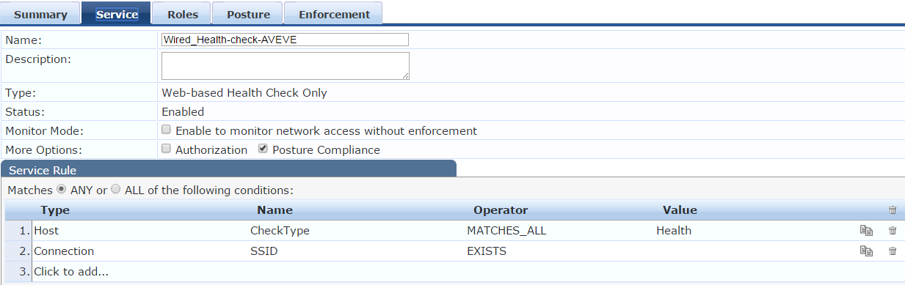

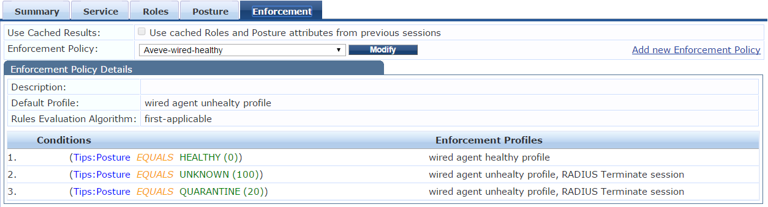

Access Tracker
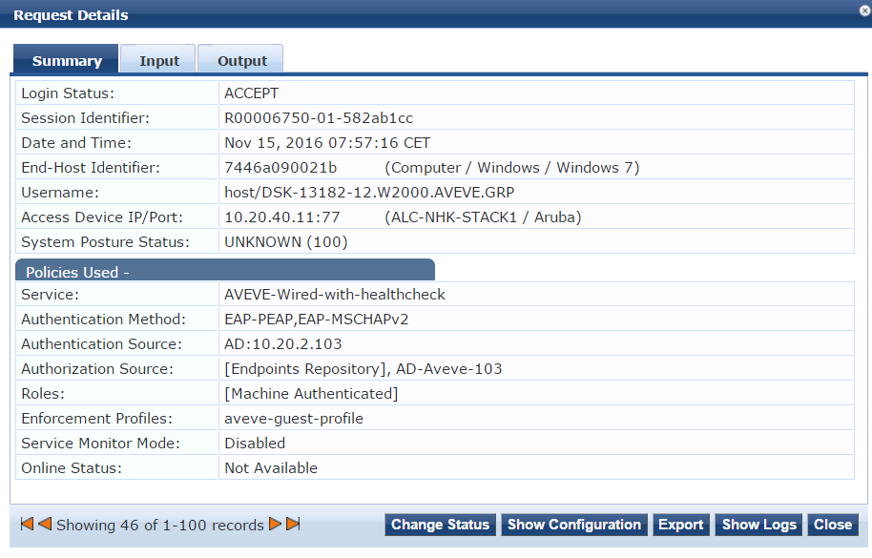
NAC in not performaing a healthchack task only fort his system and certian time period. But it perform good for all other system.
