-In regards to how to pass back a different vlan depending on what ap group the user is originating from.

You will have to configure a Role and role mapping and enforcement profile and policy
- Create the roles
Roles: created AP-Group10 Users and AP-Group20 Users (they are only label you identified)
- Role Mappings: Created a Mapping with 2 conditions that states anyone connected to AP-Group10/20 is assigned to the: Role AP-Group10 Users and 20
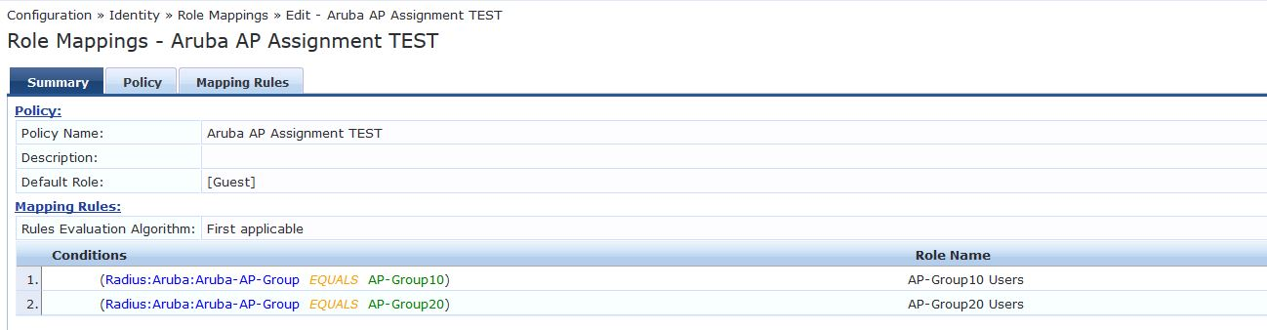

Create the Profiles (action that assigns the VLAN)
TEMPLATE: Aruba RADIUS Enforcement
- I create the first one the copy it and change the name and vlan
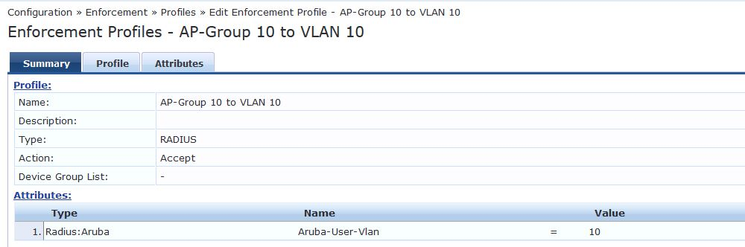
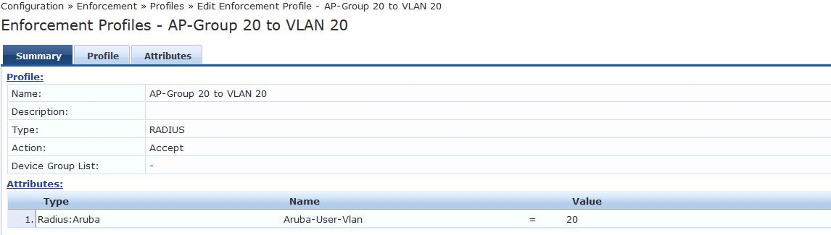
Create Enforcement profile
-Rules that states for the Role AP-Group* Users do Action AP-Group* to VLAN *
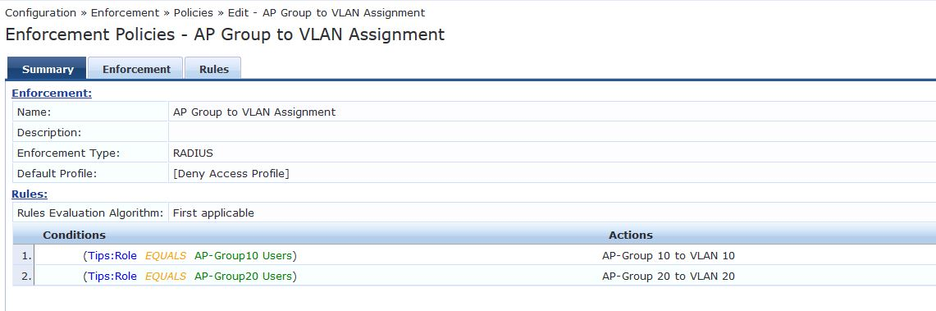

I used the following reference and built on it. Good Luck
https://community.arubanetworks.com/t5/Security/VLAN-assignment-with-clearpass/td-p/223834

