Bert Church RFP Licenses
Customer PO: | 4300197996
Reseller / End user PO: | AE3469
Aruba Sales Order: | 0005217706
Aruba Part Number: | LIC-RFP-1
Description: | RFP License (WIP+Spectrum) (1 AP)
Contact: | jim.mcmanaman@bell.ca,elisa.brathwaite@bell.ca,jim.mcmanaman@bell.ca
CERTIFICATE ID: | U6F+1US+-hlI/CwW8-tjMhjvVJ-yK93+C7n
Serial Number: | L0000658726
-----------------------------------------------------------------------------------------------------------------------

Customer PO: | 4300197996
Reseller / End user PO: | AE3469
Aruba Sales Order: | 0005217706
Aruba Part Number: | LIC-RFP-1
Description: | RFP License (WIP+Spectrum) (1 AP)
Contact: | jim.mcmanaman@bell.ca,elisa.brathwaite@bell.ca,jim.mcmanaman@bell.ca
CERTIFICATE ID: | nINIFES+-hlJ7F+f/-XPaiF/sb-rgj8oQIp
Serial Number: | L000065873
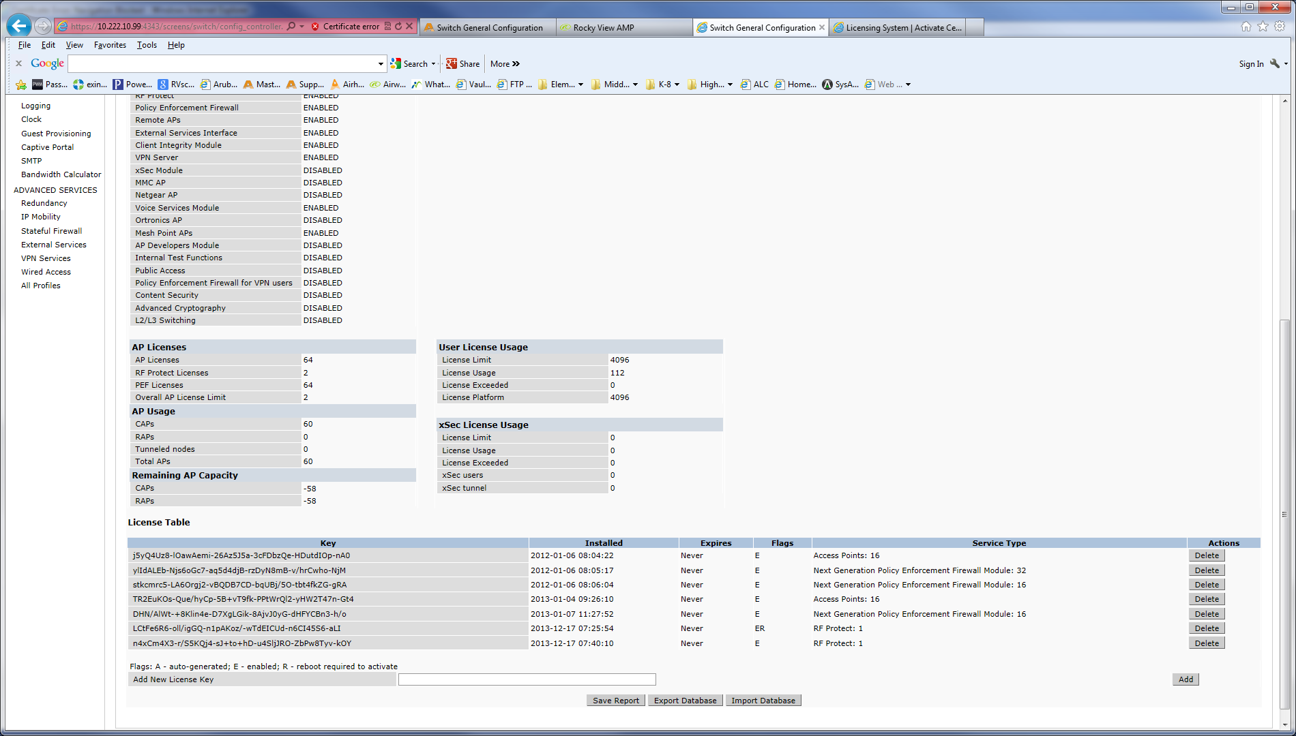
Is this normal

The 2 RFP Licenses that I installed on this controller

When I reboot the controller only the first 2 APs that the controller sees will show up.
I have not rebooted the controller yet that is why it still shows 60 APs.
Is this normal when installing RFP Licenses

