MERIDIAN BEACON MAP CHANGER

No IPHONE REQUIRED

No SMARTPHONE REQUIRED

Description
Meridian map-changer is a script relying on the meridian API, which, given a meridian location-id (read a meridian account) and a token for authentication let you change a beacon from a map to another.

Use cases
- The original use case comes from the fact I had registered the beacons before uploading a new map to Meridian, so the beacons were not associated to the correct map. The registering phase led me borrowing a iPhone from a colleague (because I am a very happy owner of an Android phone)… and I wanted to avoid bothering him again…
- Another use case concerns PoC: it might be necessary to reassign some beacons to a new map and if you don’t have a iPhone you can’t do even that…
- Yet another case is that you are not close to the beacons: the beacon App requires an iPhone but also to be close the beacon to reassign it!

Disclamers
- No, map-changer cannot “onboard” a new beacon, each new beacon has to be already associated to your location using the Beacon App that only exist on iPhone
- No, map-changer cannot change tags of map for now (maybe in the future)
- No, map-changer cannot move a beacon from a location to another, only between to maps of the same location
- No, this is not a product and it has no warranty of anything suiting for your need, for that reason it is released under the GPLv3
- Yes, you can modify and adapt map-changer at your will but need to be compliant with the GPLv3: https://www.gnu.org/licenses/gpl-3.0.en.html

Requirements
- A linux/MacOS X computer with the curl program available or a windows PC with Cygwin with curl installed in.
References:
- Cygwin http://www.cygwin.com/
- Curl https://curl.haxx.se/

Thanks
Thanks to Vincent Blavet during a discussion, for having let me realized that I had overlooked what was possible to do with the meridian API.

Where to get map-changer?
Here embedded in this document:
(under Windows, better read the file using wordpad)

Let’s rock!

Obtain your Location-id (your account number)

Connect your web browser to the Meridian Editor: https://edit.meridianapps.com/login
login with your credentials
select the location of the beacon(s) you want to change of map

the location-id is available in the URL that then shows on your browser:

https://edit.meridianapps.com/apps/<location-id>/versions/1/dashboard/

Or click on the bottom left menu “location” see the screenshot below:

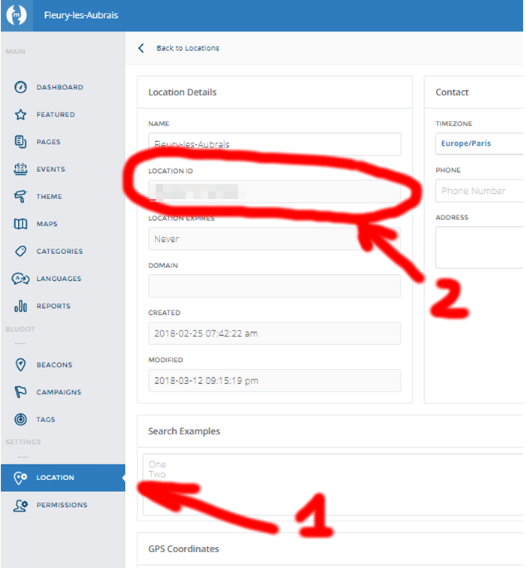

Keep this location-id for further references

Obtain a API token

While still logged on the Meridian Editor (and thus while your browser has still a cookie to authente to the portal) modify the URL by the following one and hit the <enter> key for validation:

https://edit.meridianapps.com/api/tokens

You should see your browser displaying a small json snippet of the following form:

"results": [
{
"token": "xxxxxxxxxxxxx",
"created": "2018-02-08T10:05:39.049300",
"email": "your@email"
}
]

Grap token string, here the xxxx part an keep it for the next step (without the quotes)

Using map-changer

In a terminal, run the command without argument to have a view of its syntax:

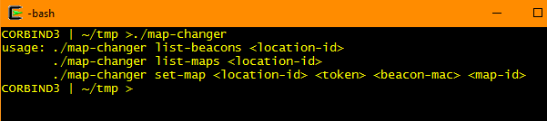

The command that operates the change is the latest syntax:

map-changer set-map <location-id> <token> <beacon-mac> <new-map-id>

Notes:
You can get the beacon’s mac address from the Meridian Editor (menu beacons then select “list” on the top right of the window), or you can run map-changer with the argument list-beacons followed by the location-id you already have obtained previously:
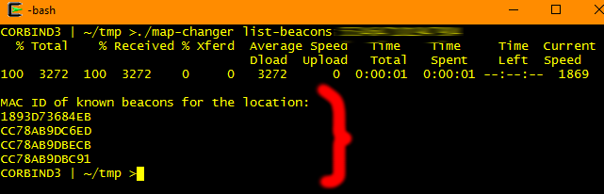

You can get the map identifiers of the location from the Meridian editor (menu MAPS, then select a map and read the URL) or run map-changer with the argument list-maps
