This VC is seeing in the Airwave:

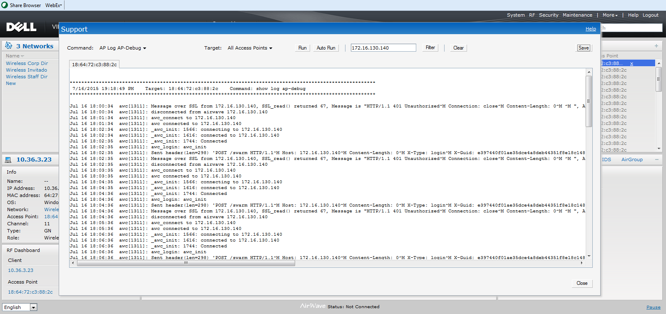

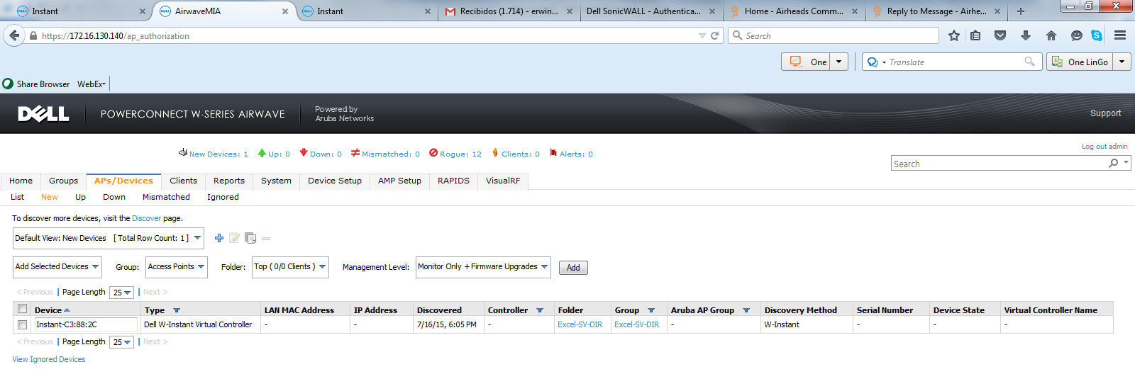
This is not working and not generating any messages to the Airwave:

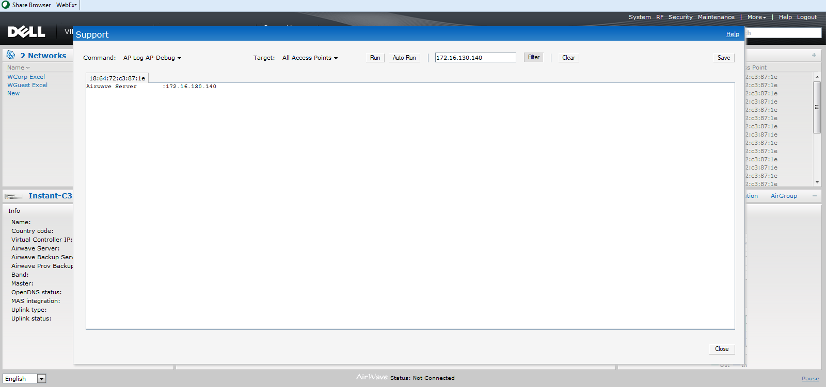
The output of this command is “connection-failed” in the IAP that is been seeing in the Airwave server, but is not yet imported:

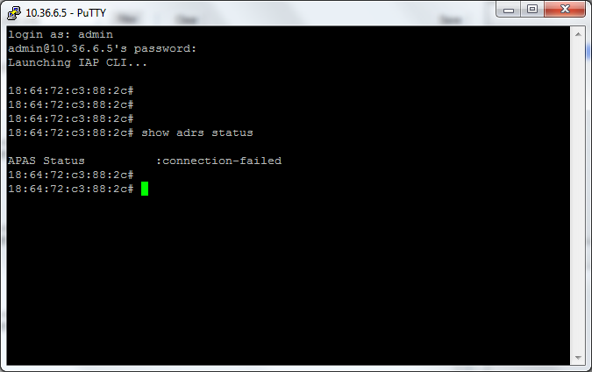

But for the other one appear as disabled:

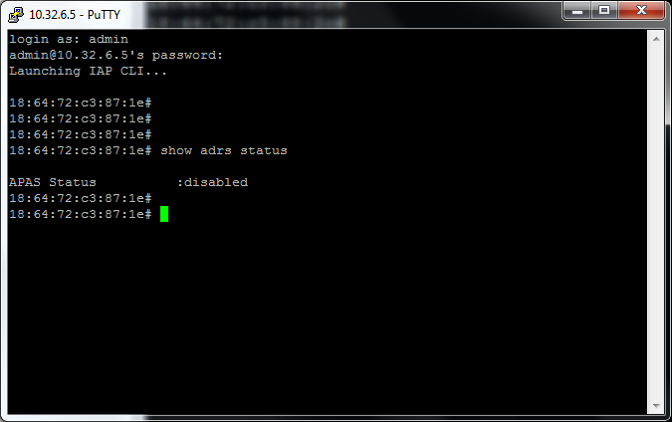

http://community.arubanetworks.com/t5/Controller-less-WLANs/How-to-setup-the-Instant-Access-Point-to-connect-to-Airwave/ta-p/180072

