Issue with mac-auth and self-sponsoring.
Thread: http://community.arubanetworks.com/t5/Security/HowTo-Auto-Sponsor-with-Clearpass-Guest/m-p/255232
Guest role mapping
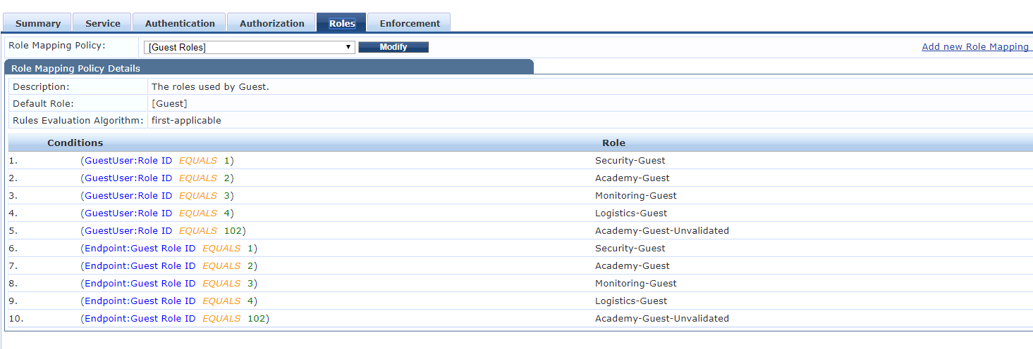
Captive portal service
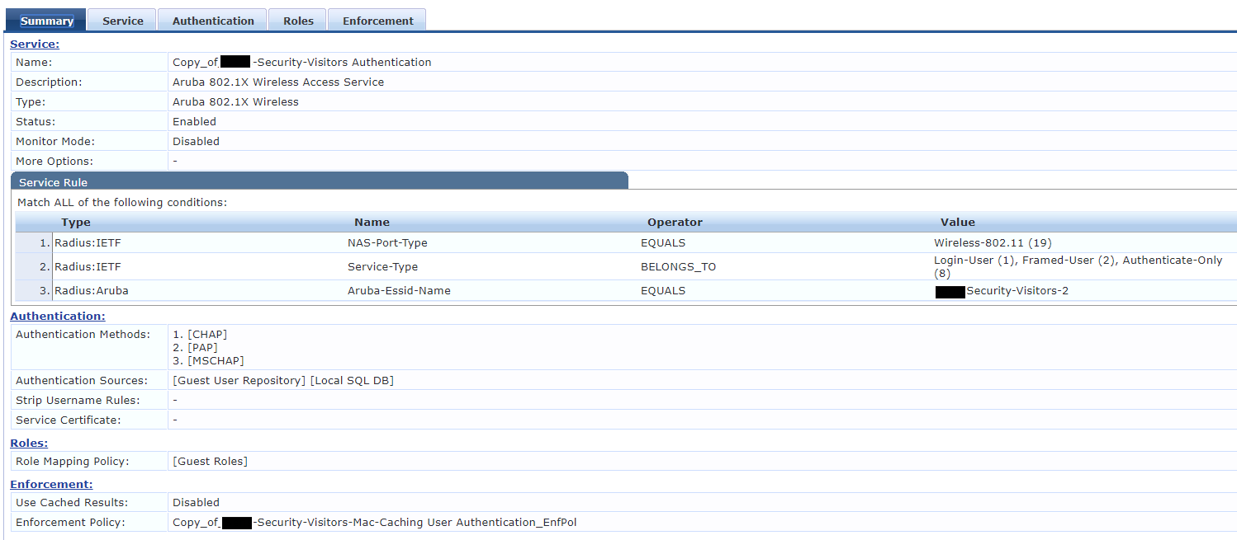
Enforcement policy for captive portal auth
Mac auth service
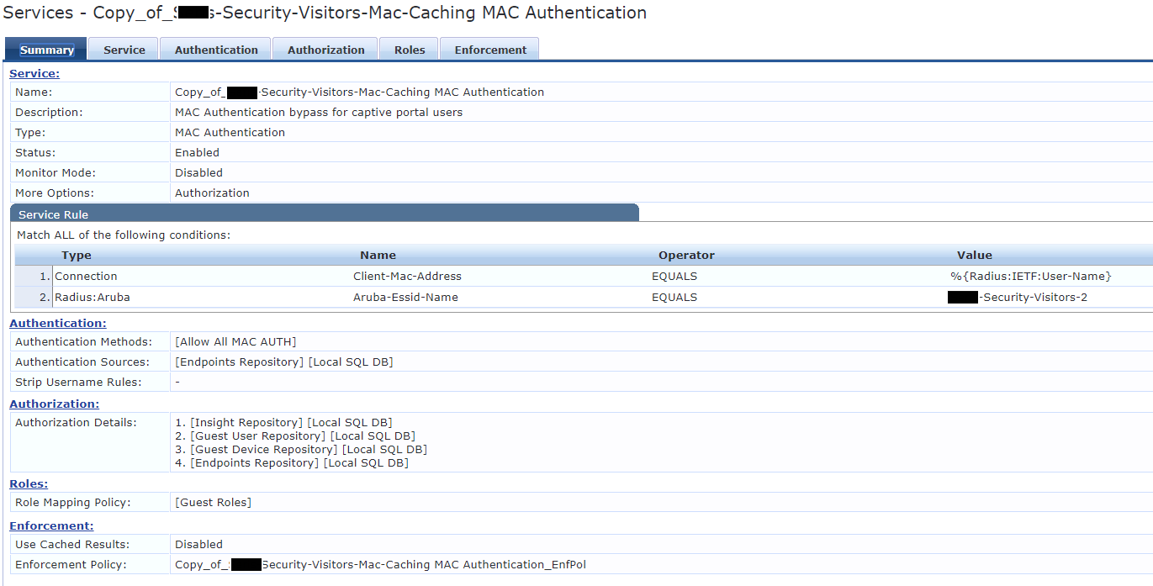

Enforcement policy for mac-auth
This is not the exact one I was using in the access tracker log in the bottom. But the issue is related to the service not being able to translate %{GuestUser: attributes. So this policy does not even work atm.
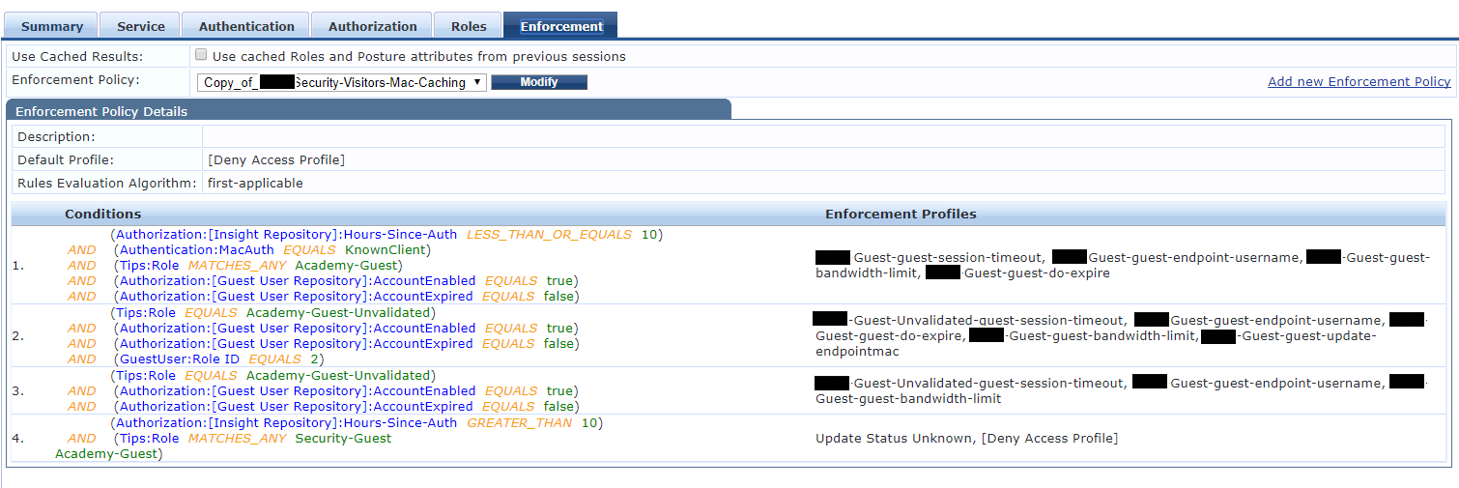
Enforcement profile do-expire
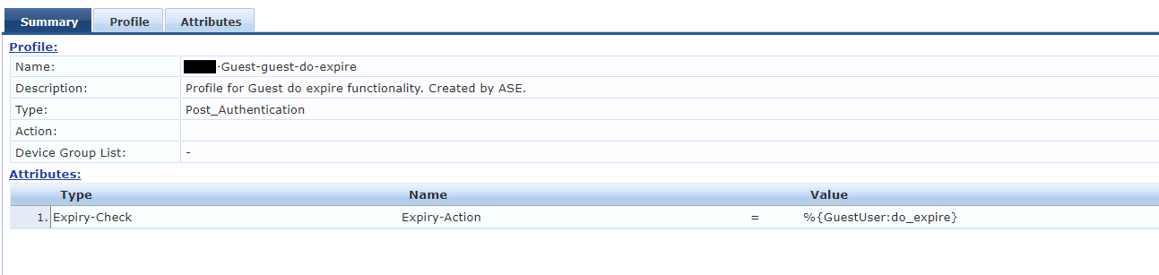

Enforcement profile session-timeout
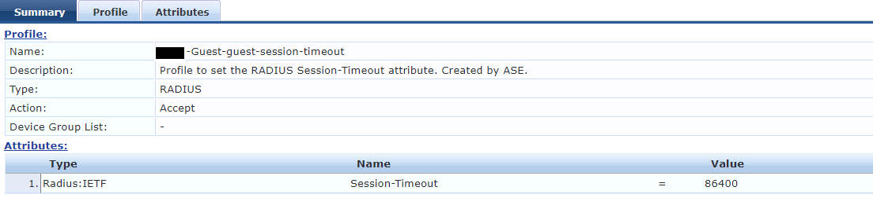
Enforcement profile unvalidated-session-timeout
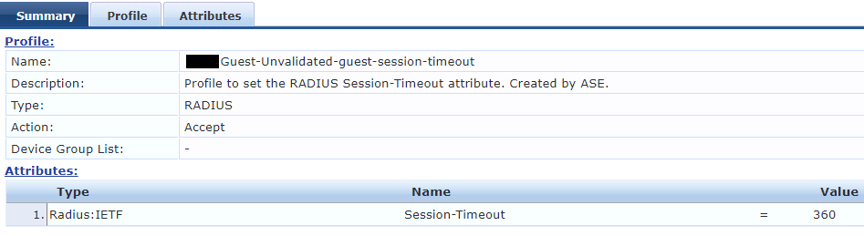
Enforcement profile update-endpointmac
This profile should update the endpoint role id with the current guestuser role-id
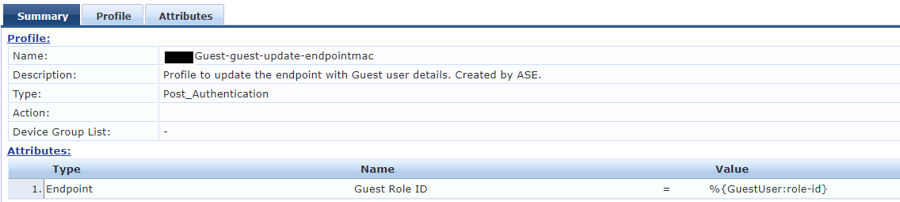

Role id in the registration field
This role is set to the unvalidated role
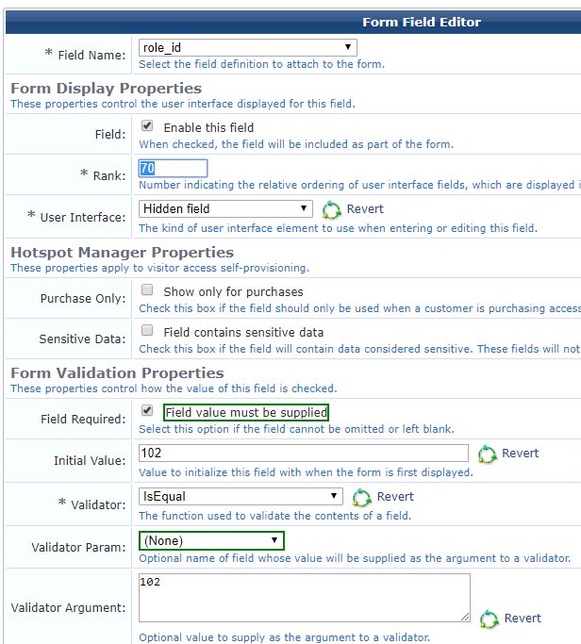
Sponsor account overrides
This adds the 24 hours and changes the user role
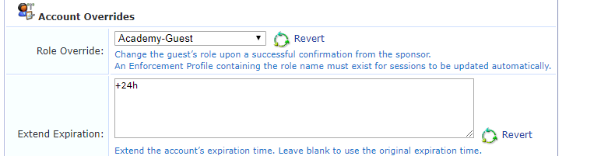

Access tracker for MAC-auth
As you can see here, %{GuestUser attributes are not translated to their value. They are stored as such in the endpoint attributes.
As in the additional document in the thread, do-expire is added to mac-auth but here it just doesn’t work. The endpoint guest role cannot get updated as well.
