User Connectivity Flow
Step 1
User connects to Visitor SSID.

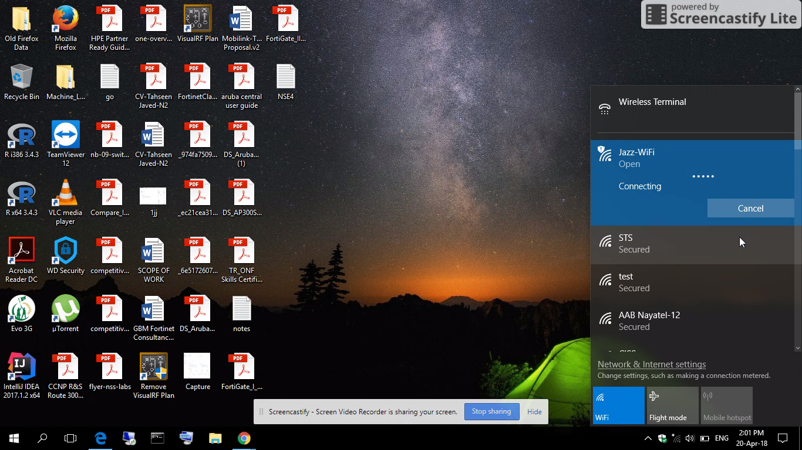

Step 2
SSID will automatically redirect to Captive Portal Page.

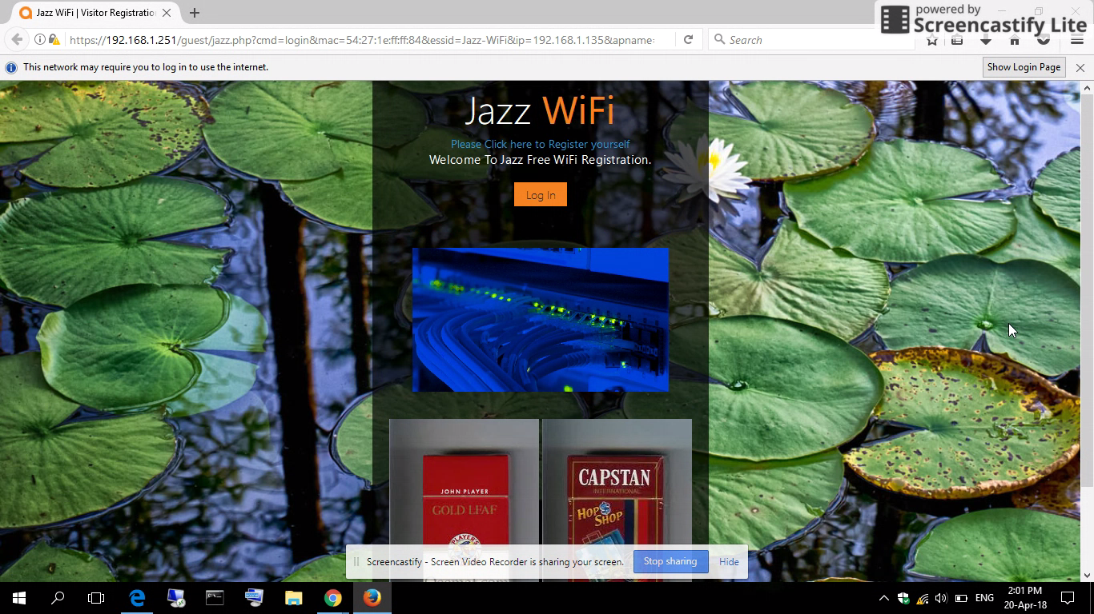

Step 3
User have to click on “Please click here to Register yourself” to submit user information.

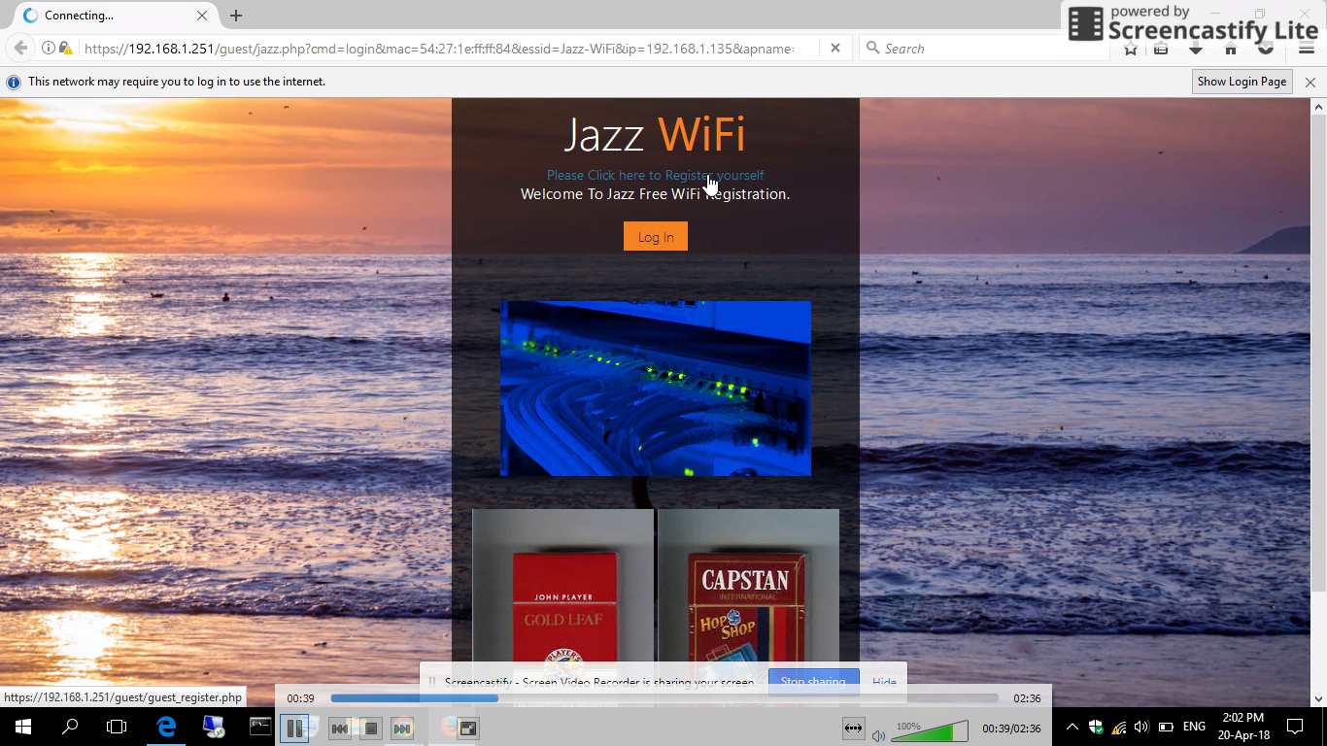

Step 4
User will be prompted if his/her age is less than 18 years.
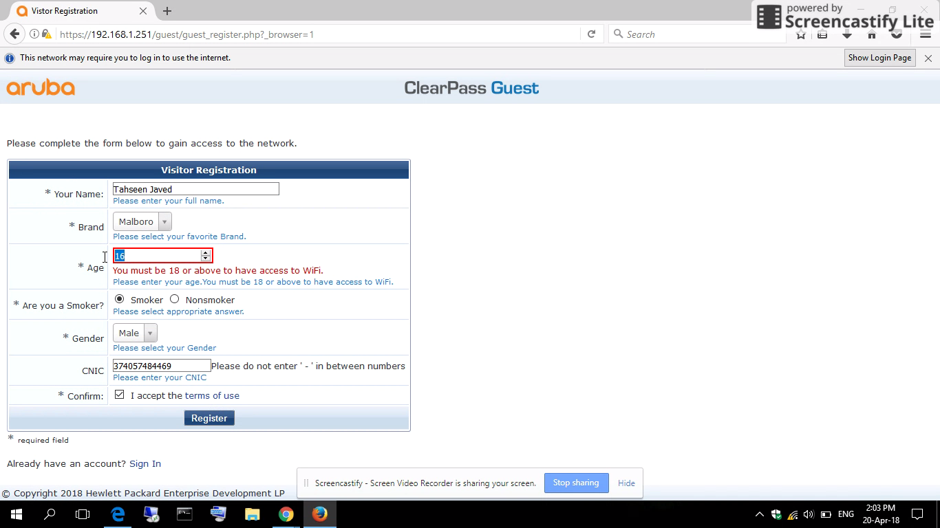

Step 4
User will be prompted if he is Smoker or Nonsmoker.

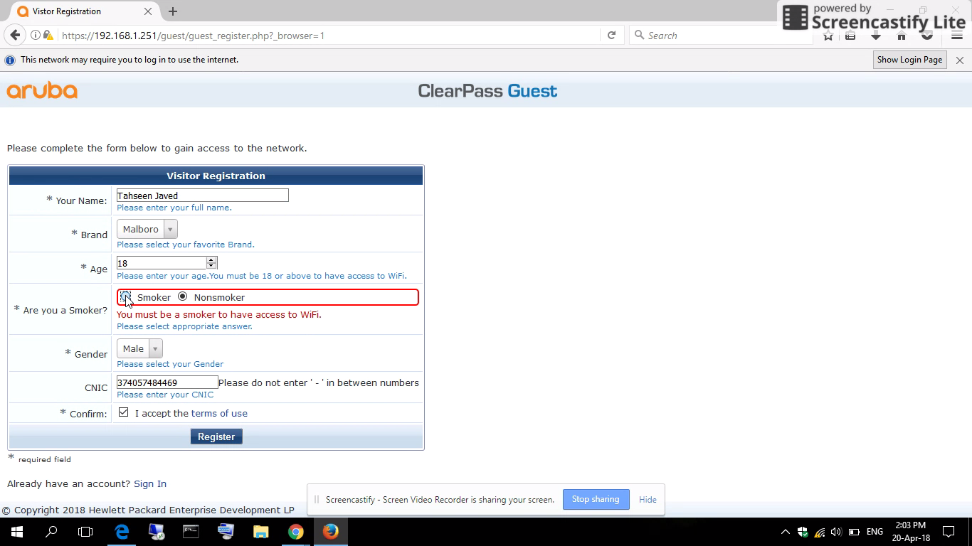

Step 5
User then clicks on login.

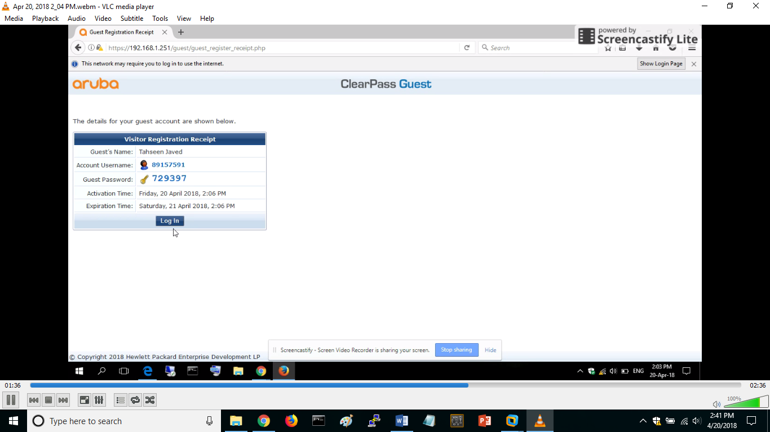

Step 6
User will then be redirected to demo.feag-games.com.

