See the 2930M configuration guide – here they mentioned more than 8 ports we can do it on LACP but
I Don’t know the commands

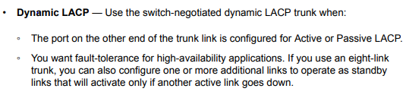

Here they mentioned 8 ports only but in the next line itself they mentioned smart links
