Follow the below procedure to provision the HP switch into AMP.
- Create a .csv file in the format attached. Change the Name, LAN MAC, Serial Number, Group Name and Folder Name accordingly based on the devices that are going to be imported.
- You can insert custom_variable_1, customer_variable_2 …customer_variable_10 by adding columns. I have added five customer variables in the attached excel sheet.
- Login to the AMP and click on the “New Devices” and click on the “Instant AP & HP Provision Switch Whitelist as shown below:
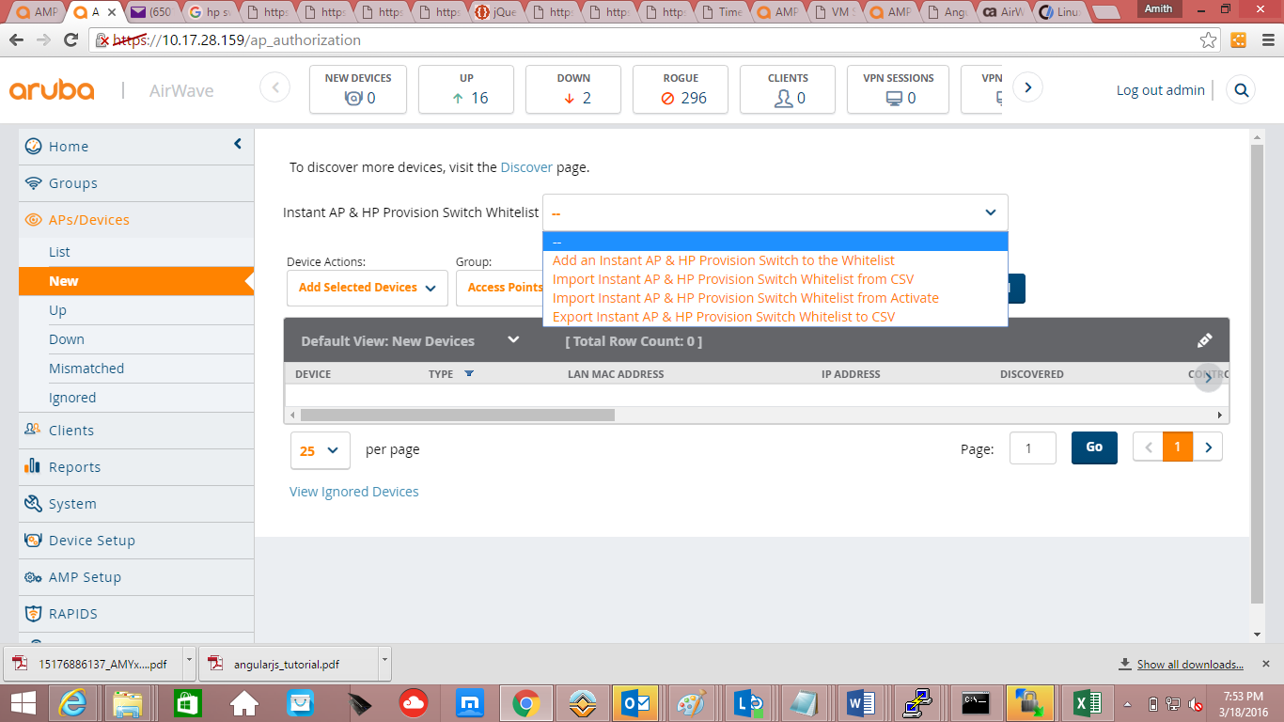

- Select the second option “Import Instant AP & HP Provision Switch Whitelist from CSV.
- Ensure that the devices that you are going to import are not present in the AMP already. If Present, then delete them before performing the import. Otherwise, you will get the below error.
Error parsing line 2 (Name:HP-Stack-2920, LAN MAC:B0:5A:DA:2E:6A:C0, Serial Number:SG59FLX7FZ): Already authorized device.
- You will get the below option
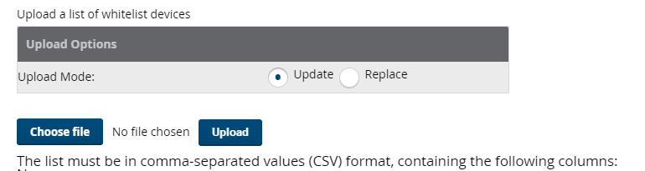
- Now click on “Choose file” and select your populated .CSV file and click on Upload Button.
- If no errors are thrown, then the import is successful and you will get the rows created as below depending on the number of rows in your excel sheet:
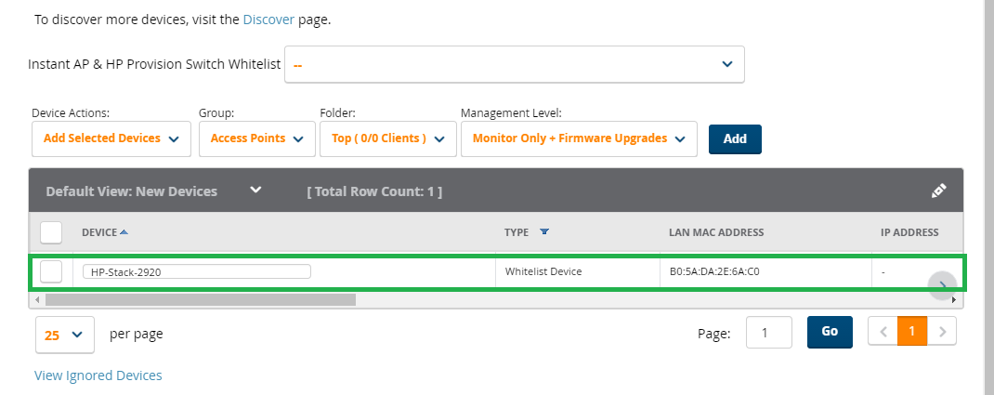
- Now go the switch CLI of the device that you are going to ZTP using amp-server command and issue the below command depending on your AMP IP Address.
amp-server ip <amp ip address> group <groupname> folder <foldername> secret <secret123>

Ex: HP-2920-24G-PoEP(config)# amp-server ip 10.17.28.159 group mygroup folder myfolder secret secret123
- Once the command is executed successfully,
- Device will be created in the groupname namely s3800 and folder name Top specified in the imported .csv excel sheet and will show UP in the AMP as shown below.
Created five dynamic variables at the end as shown below:

Check the monitor page of the device and note down the device id. Ex 47 in below case.
https://10.17.28.159/device_config?id=47
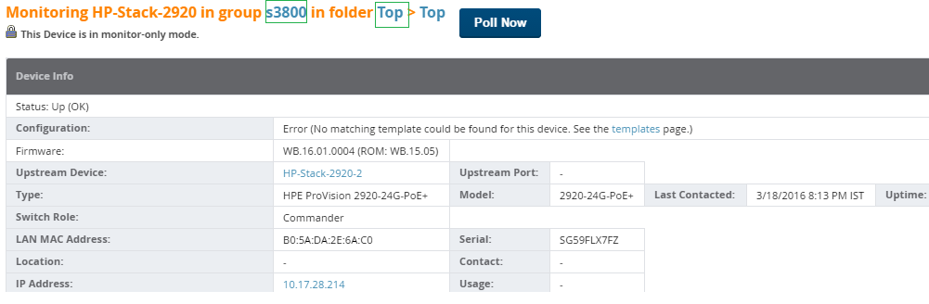

- Now check the database for the initialization of the dynamic variables as shown below using the device id as shown above:
airwave=> select * from ap_dynamic_variable where ap_id=47;
id | ap_id | name | value
----+-------+--------------------+---------------------
12 | 47 | dynamic_variable_1 | disable
13 | 47 | dynamic_variable_2 | power-over-ethernet
14 | 47 | dynamic_variable_4 | link-keepalive
15 | 47 | dynamic_variable_3 | 16
16 | 47 | dynamic_variable_5 | 15
(5 rows)

airwave=>

- Then I tried delta push from AMP by Editing the template and setting the Push complete configuration file: “No”.
I edited the template to create a new interface 13 and added lines as below:

interface 13
no %dynamic_variable_2%
%dynamic_variable_1%
exit

- Set the device to Manage read/write and checked the configuration Log and Telnet/ssh log for config push by clicking on hyperlinks in the audit page.
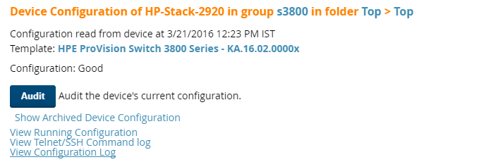
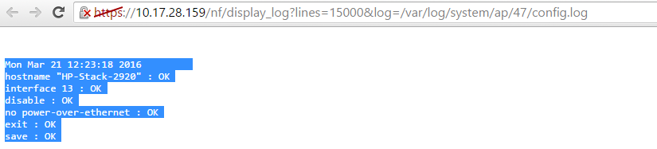

Telnet/ssh log below:
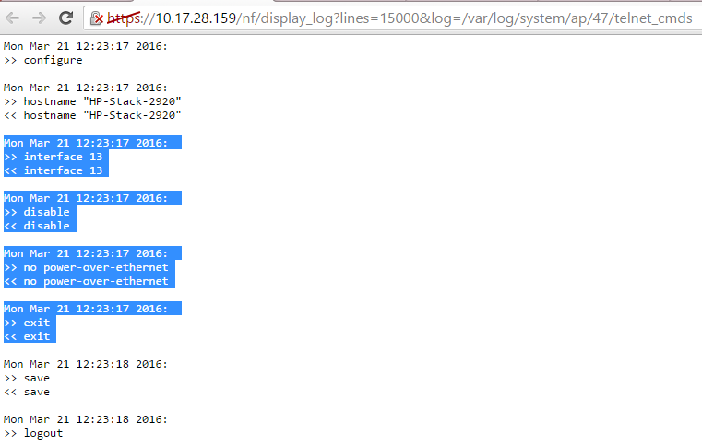
- Checked the switch CLI and config push is successful and device is in Good state in AMP.
