Policy Based Routing
A policy-based routing rule is an ACL that can forward traffic as normal, or route traffic over a VPN tunnel
specified by an IPsec map, routed to a nexthop router on a nexthop list, or redirected over an L3 GRE tunnel or
tunnel group.
A Policy Based Routing rule does not become active until it is applied to a VLAN interface or user role.
To associate a policy based routing rule with a managed device:
1. In the Managed Network node hierarchy, navigate to Configuration> Interfaces > IP Routes.
2. Expand the Policy-Based Routing menu.
3. Click + below the Policies table to create a new policy. When you add a new policy, the Add Policy window
appears and prompts you to name the new policy. The policy type (route) is predefined in this window.
4. Select the policy in the Policies table. The Policies > (policy name) table appears.
5. Click + to add a new policy.
6. The New Rule window opens. Select a rule type
n Access Control: Applies the rule to all traffic, or traffic using a specific service, protocol, or TCP/UDP port
or range of ports.
n Application: Applies a rule to an traffic for an application or application category.
7. Configure the rule parameters.

Table 46: Policy Based Routing ACL Rule Parameters
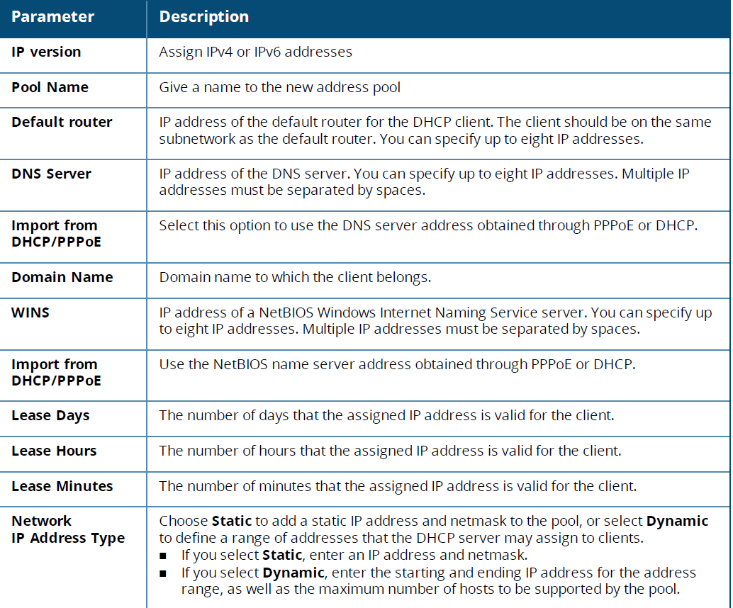
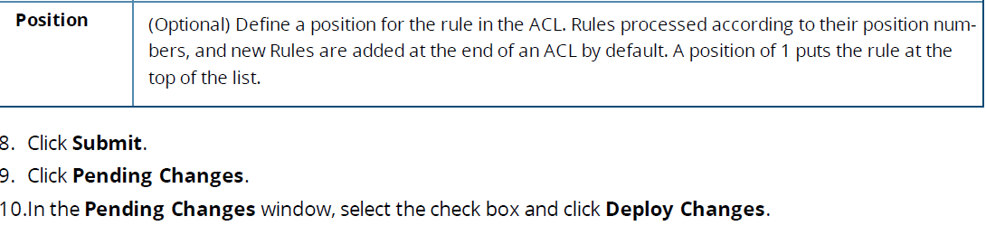
Targets for PBR Rules
Use the command routing-policy-map to associate a routing ACL with a specific user role on a managed device.
n If you selected the VLAN type, click the Target drop-down list and select a VLAN ID to apply the rule to
inbound traffic on the VLAN interface.

