AirWave
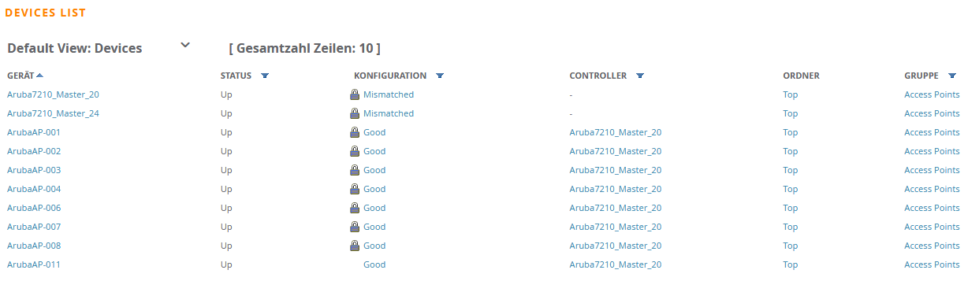
Klick on Mismatch of the Atuba7210_Master_20
