We can able to add more than 8 ports on comware side.
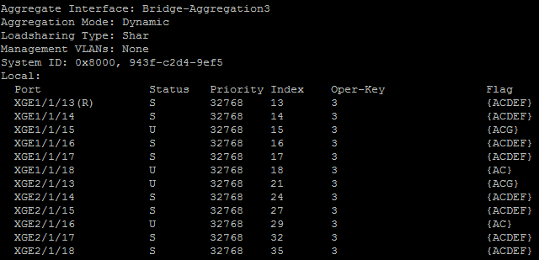

ON Procurve/Aruba switch we can able to add only 8 ports. It is not allowing us to add more than 8 ports.
