Time based SSID on Instant Access Point
Author | Vishal Mann vishal.mann@hpe.com
Contributor | Sandeep Yelburgi  sandeep.yelburgi@hpe.com
Date | 25 July 2016
Document version | 0.1
IAP details | SW: 4.2.4.0_55341

Introduction
In Instant 6.4.3.4-4.2.1.0, IAPs allow you to enable or disable an SSID for users at a particular time of the day.
You can now create a time range profile and assign it to a WLAN SSID, so that user access to the Internet or network is restricted during a specific time period.
IAPs support the configuration of both absolute and periodic time range profiles. You can configure an absolute time range profile to execute during a specific time frame or create a periodic profile to execute at regular intervals based on the periodicity specified in the configuration.
Consult the IAP user guide for more details on the feature. This example will cover one specific use case, SSID should be available from 7 am to 6 pm, on weekdays.

Configuration

Pre requisite
Time-based services require an active NTP server connection. IAPs use the default NTP server, pool.ntp.org, for time synchronization. However, the administrators can also configure an NTP server on the IAP. To verify the time synchronization between the NTP server and the IAP, execute the show time-range command and check if the time on the NTP server is in synchronization with the local time.

GUI
- System>show advanced options>Time Based Services
Create a new profile as shown below.
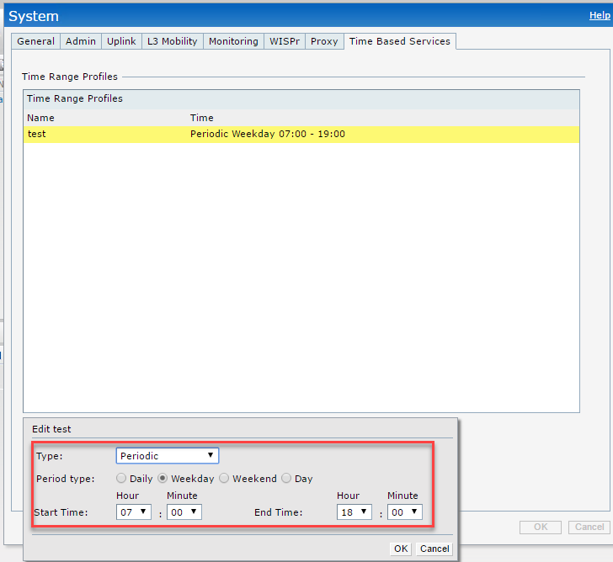

- SSID WLAN settings>show advanced options>Time Range Profiles

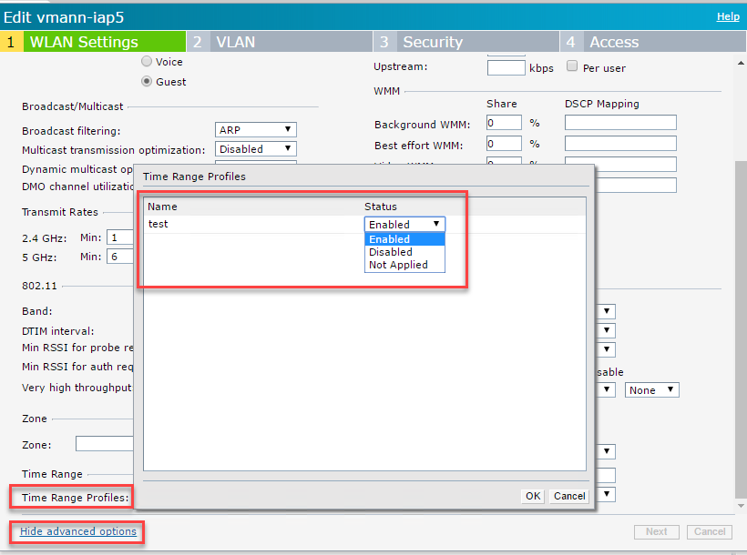
The time profile created previously should be available, to choose from three options.
- Not applied, will result into no effect.
- When a time range profile is enabled on SSID, the SSID is made available to the users for the configured time range. For example, if the specified time range is 12:00 to 13:00, the SSID becomes available only between 12 PM to 1 PM on a given day.
- If a time range is disabled, the SSID becomes unavailable for the configured time range. For example, if configured time-range is 14:00 to 17:00, the SSID is made unavailable from 2 PM to 5 PM on a given day.
In this case we will choose enabled.

CLI
time-range test periodic weekday 07:00 to 18:00
→create the time profile between 07:00 to 18:00

wlan ssid-profile vmann-iap5
→The WLAN configuration
disable
→disable the ssid all the time
time-range test enable
→enables at 07:00 and disable it at 18:00 (so it will be enable between 07:00 to 18:00)
exit
commit apply

In the above example we create an ssid and disable it all the time and enable it only when it required by time profile.
If user configures the time range and attach it ssid at 08:00 then ssid will be disabled till next day 07:00 or else reboot the AP to have immediate effect. I choose to reboot the AP.

Verify
Check current time.

IAP# show clock

Current Time :2016-07-25 17:11:28

Check the time based profile.

IAP# show time-range

Current Time :2016-07-25 17:11:30
Time Range Summary
------------------
Profile Name Type Start Day Start Time End Day End Time Valid
------------ ---- --------- ---------- ------- -------- -----
test Periodic weekday 07:00 - 18:00 Yes

Notice the Valid field is set to “Yes”. That means the profile is currently into action, and has enabled the SSID.

IAP# show time-profile

Time Range SSID Profile
-----------------------
Time Profile Name SSID profile Name Enable/Disable
----------------- ----------------- --------------
test vmann-iap5 Enable

This command shows the SSID to time profile mapping and action behavior, enable/disable.
Change the time to any time past 18:00.
IAP# clock set 2016 07 25 19 01 00
IAP # show clock

Current Time :2016-07-25 19:01:02

Check SSID broadcasted.
IAP# show ap bss-table

Aruba AP BSS Table
------------------
bss ess port ip phy type ch/EIRP/max-EIRP cur-cl ap name in-t(s) tot-t
--- --- ---- -- --- ---- ---------------- ------ ------- ------- -----

Channel followed by "*" indicates channel selected due to unsupported configured channel.
"Spectrum" followed by "^" indicates Local Spectrum Override in effect.

Num APs:0
Num Associations:0

Check valid field in time range.

IAP# show time-range

Current Time :2016-07-25 19:01:27
Time Range Summary
------------------
Profile Name Type Start Day Start Time End Day End Time Valid
------------ ---- --------- ---------- ------- -------- -----
test Periodic weekday 07:00 - 18:00 No

Conclusion
4.2.1.0 onwards one does not AMP templates for time based SSIDs, and IAP natively can support it. Remember that default setting of SSID is important, as time based profile’s behavior is on top of it.

