An effective workaround for this is the following.

Remove the session timeout for the MAC Caching service.

In the form for that registration page, add the do_expire field.

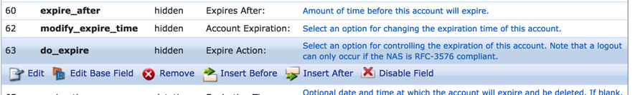

With the following values.

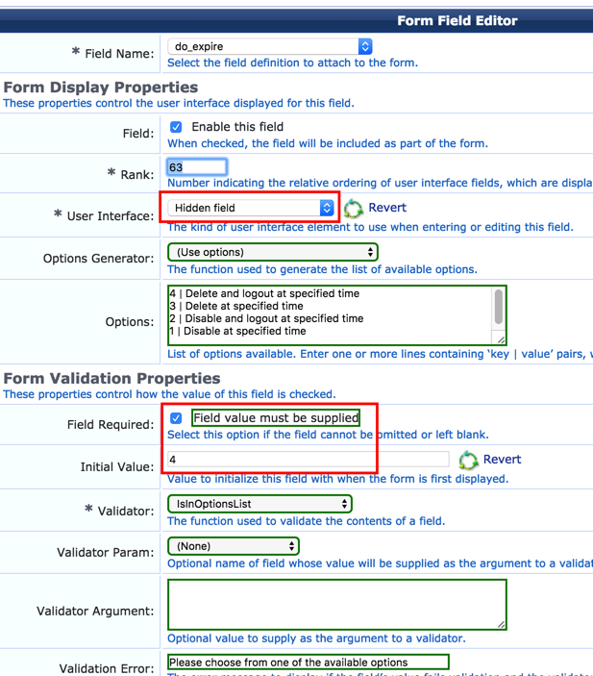

In the mac caching service, ensure the ‘MAC Caching Do Expire’ profile is being returned.  This it should be if the service has been created via the template.

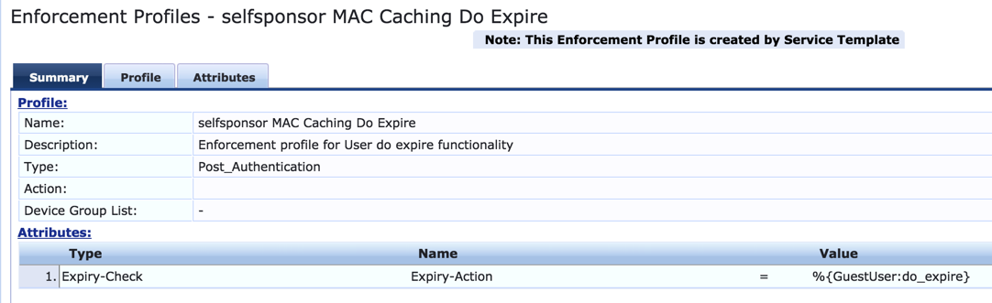

At the end of the account lifetime (5 mins), and if the user has not validated the email account, it will soon after send a CoA disconnect which will effectively force another mac-auth and the device will get put back into that registration role.

If the user does go and validates their email, then the account is extended and as such no CoA sent after that 5 mins.  Subsequent mac-auths are fine.