RedHat Linux Configuration for 802.1x

What does identity mean? What needs to be added here?????

**TLS option:**

Issue here is that we need 2 certificates and 2 private keys.

Why is RedHAT requesting a CA Root certificate? Doesn’t that defeat the purpose of having the CA root certificate on another server authenticate the client certificate? Why have both certificates on a Linux laptop?????

Doesn’t make sense.

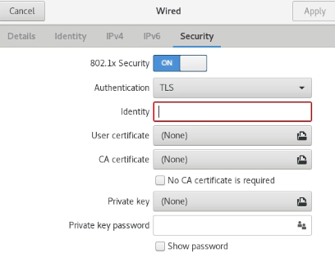

Is this where one installs the Client certificate?