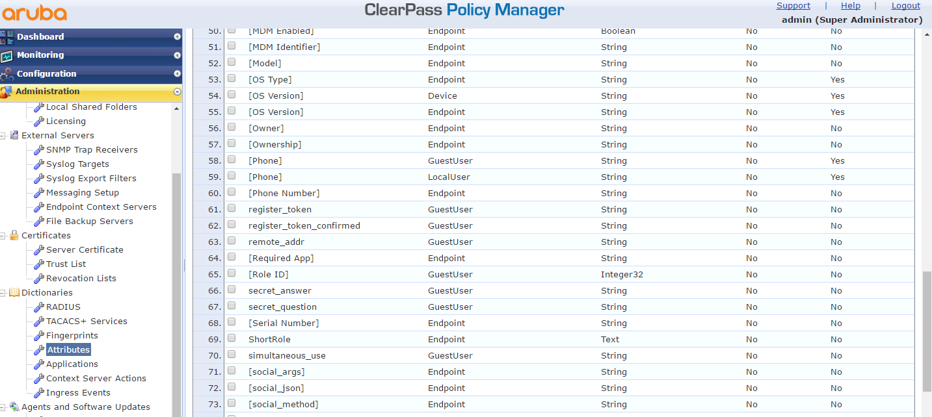
Add an attribute as below, you can write whatever you want

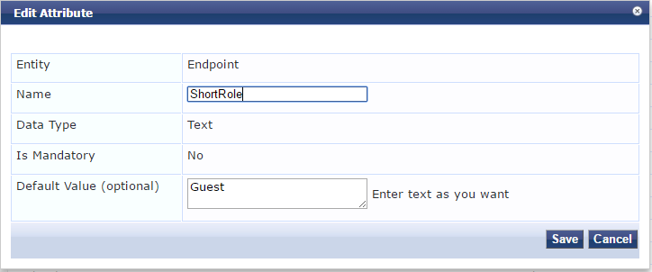

Then create a enforcement profile for the each shortrole you’re gonna use

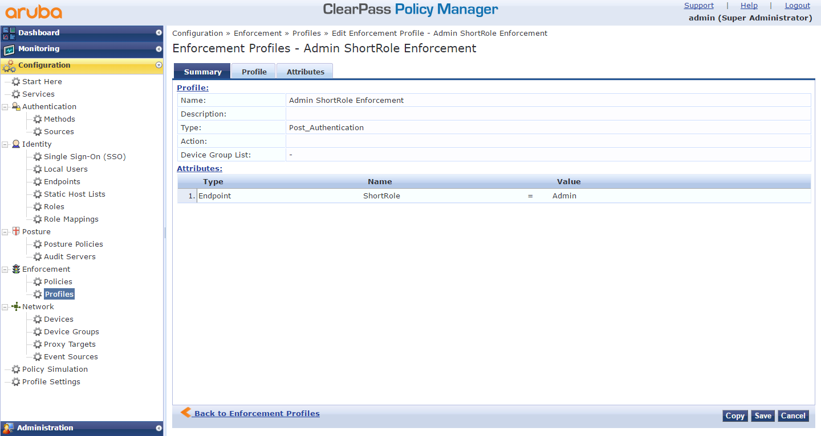

Use the short role profile in your enforcement policy

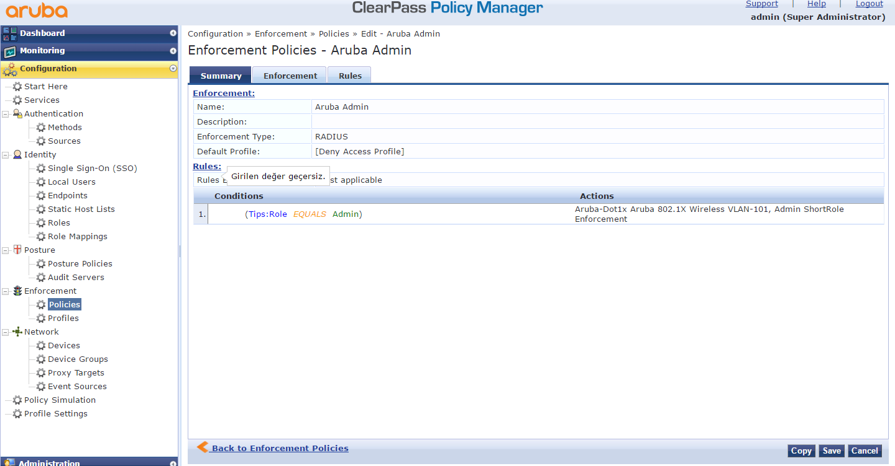

In the service change Accounting Proxy as below

