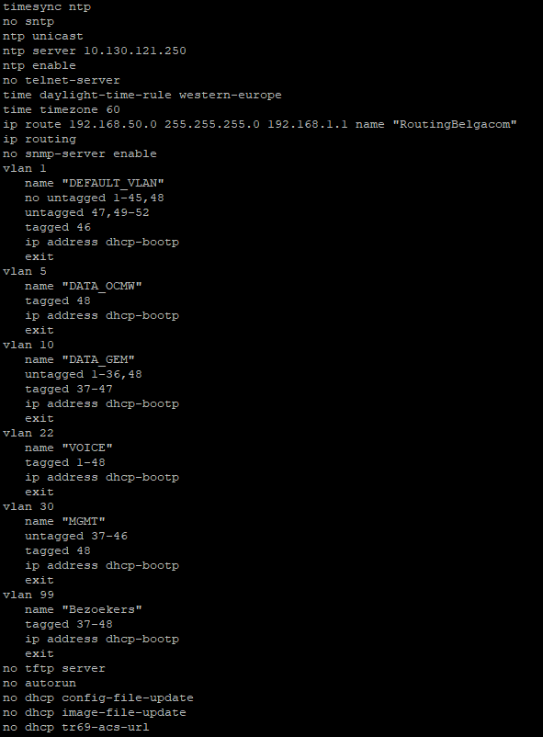

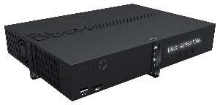

Unifi Access point

Bbox Provider

Radio Site 2

Radio Site 1

Internet

Internet

Port 46

Port 47

Aruba 2930F 48port

VLAN 10  
VLAN 22  
VLAN 30  
VLAN 99

VLAN 99 = WIFI  
Port 48 = trunkport  
Port 47 = bbox  
Port 46 = Unifi AP

Trunkport 48