Device Connection Notifcation Tutorial
This is a straight forward tutorial for creating a notification from Airwave for when a particular MAC Address connects to the network. This can be used to track lost/stolen assets, AUP violators, or for VIP alerts to make sure you keep busy when they arrive at your building.
- Log into Airwave and head to the System tab and select Triggers
- Click Add
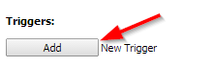
- Select “Connected Clients” as the trigger type
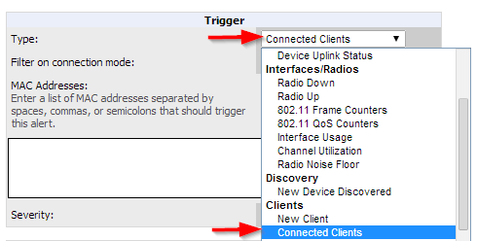
- Enter the MAC addresses of the devices you want to receive notifications for
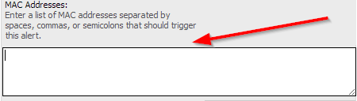

- Add a helpful Note such as this one
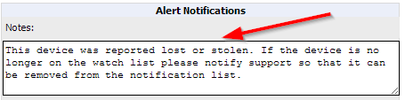
- Select email as the “Additional Notification Options”
- Enter a “Sender Address”
- Enter “Recipient Email Addresses”
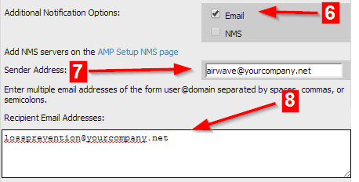
- Click Add
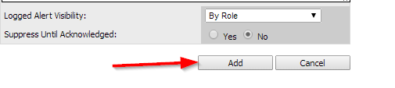
In conclusion this tutorial is used to notify a recipient via email when one or a group of particular MAC Addresses connect to the network.

