Goal, change broadcasted ssid “Invitados” to “InternetGratis”
1.- step

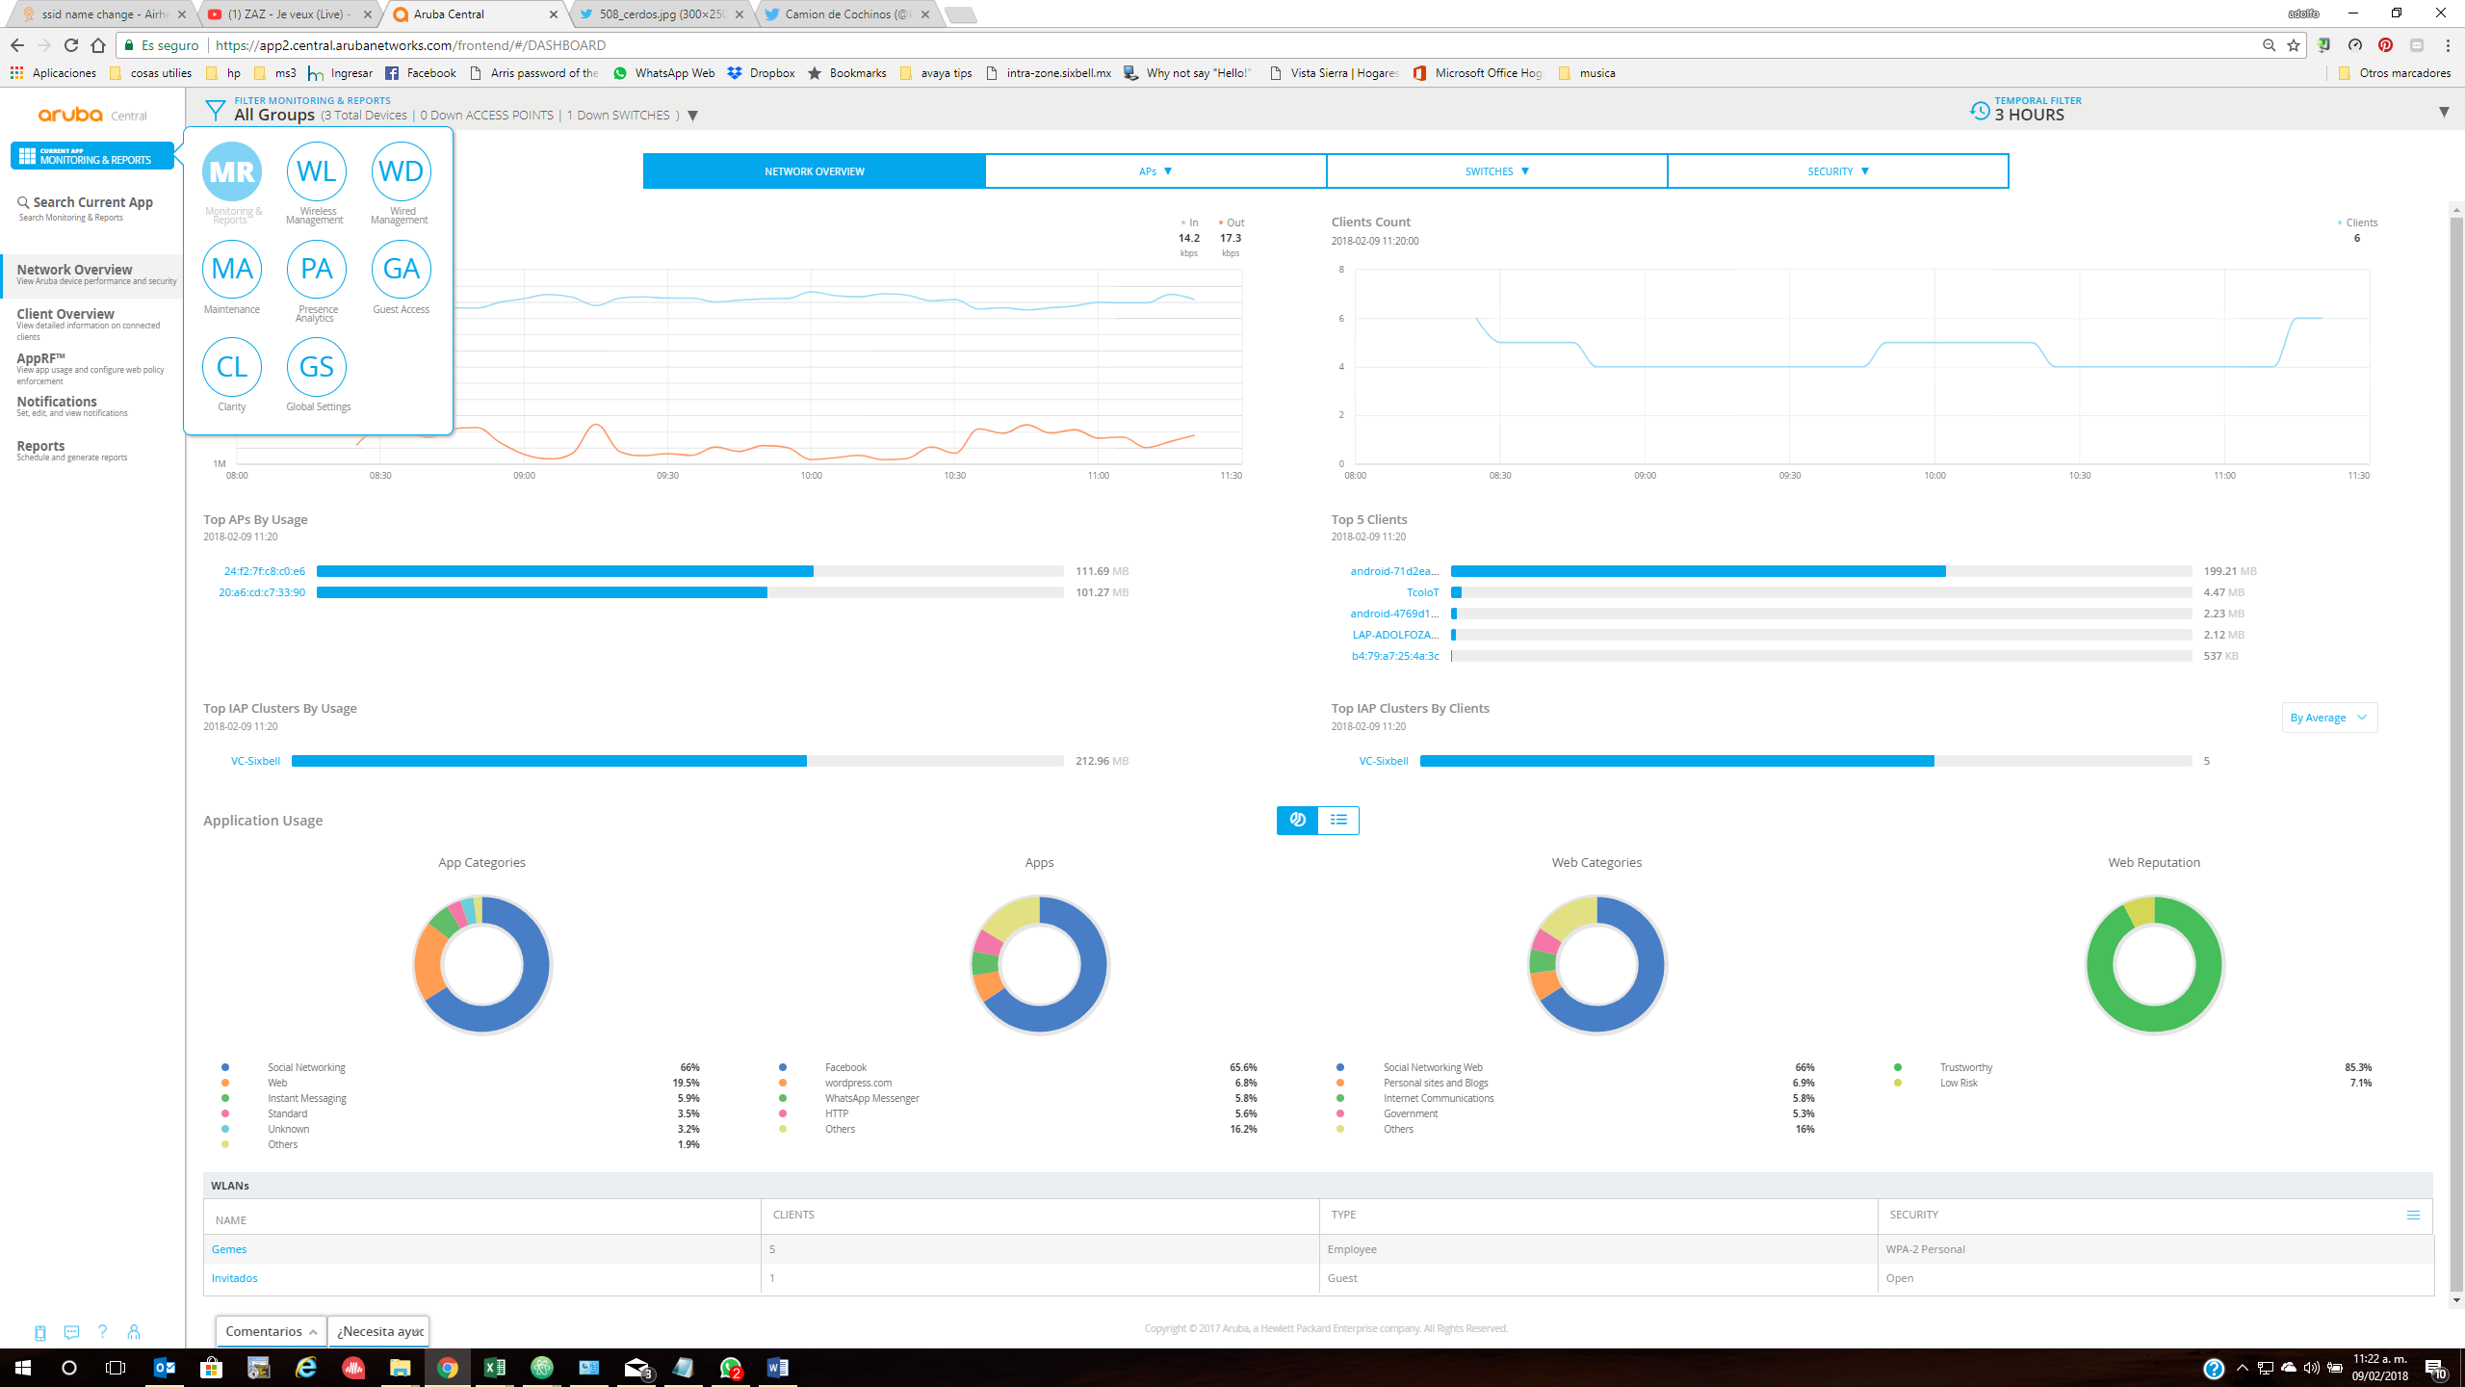

2.- step
3.-

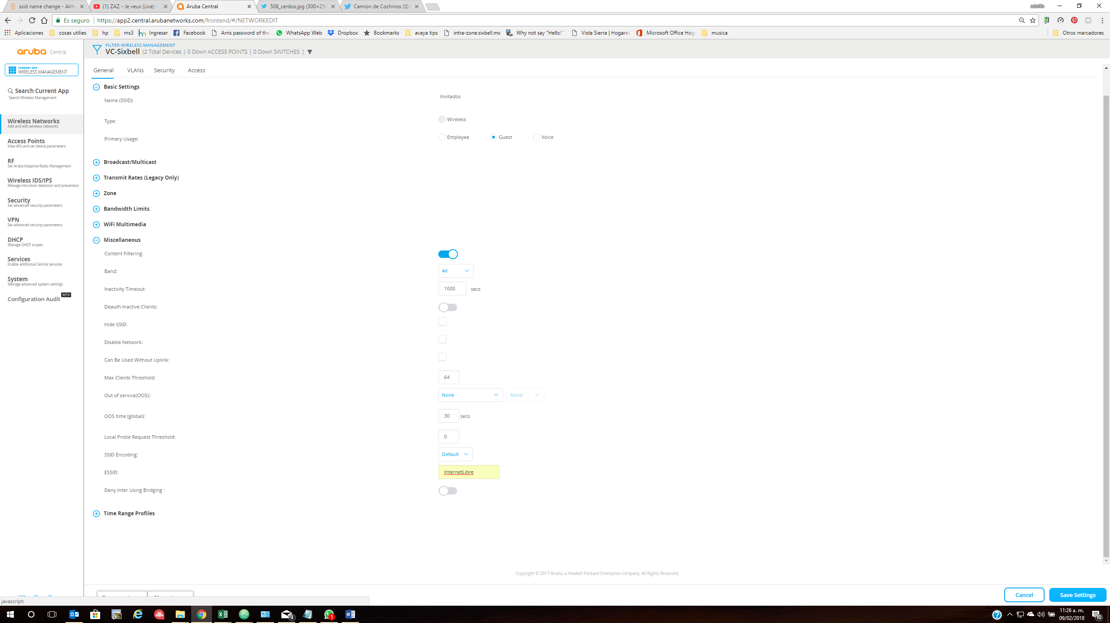

4-. When I try to save the changes, the “save settings” button appers to do nothing. At change to an another menu, the next screen appears.

