How to setup an Aruba Wireless Access Point at STRATTEC Security Corporation.

Pre-Requisites:
- Putty (or any serial console software) installed on your pc/laptop
- Serial Connection settings: Console Port settings: Baud Rate – 9600, Data Bits – 8, Parity – None, Stop Bits – 1, Flow Control – XON/XOFF
- Console port cable
- Network Access (access port) to STRATETC Wireless Access Point VLan
- Contact STRATTEC Wireless Network Administrator for Access Point login credentials.

- Connect a console port connection from your laptop to the Aruba Access Point Console port.

- Plug in Access Point VLan connection to the ‘ENET0’ port on the Aruba A.P.
  - This will initiate the A.P. to power on.
  - The boot-up process will take approximately 2 minutes and 40 seconds.

- Initiate a putty serial session while the A.P. is booting up and login when prompted.
  - One can view the boot-up process from the serial connection on your computer.
  - After you are logged into the A.P. execute the command > show ip interface<enter>
  - Document the IP Address received and its corresponding MAC Address.
  - Minimize the serial connection.

- Begin continuous pings on the A.P.’s IP address, from your computer.

- Open a web browser from a computer and type the Access Point’s I.P. Address in the address bar.
  - When prompted, enter the same user credentials to logion to the Web User Interface.

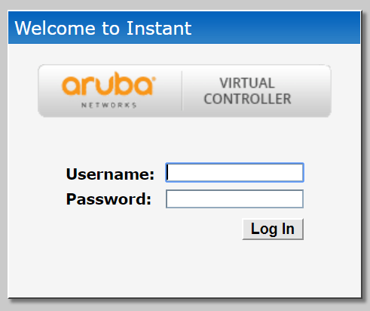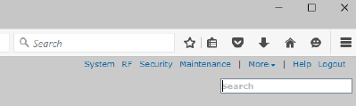

  - Close the ‘Enable Cloud Management’ pop-up window.
  - Click on the ‘Maintenance’ link located in the upper right-hand corner of the UI.
  - Click on the ‘Firmware’ tab, to see the currently installed image version.

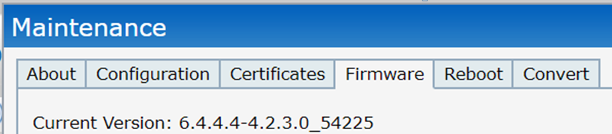

  - If version 6.4… is installed you will need to manually upgrade the A.P. to version 6.5

Continue to next page.
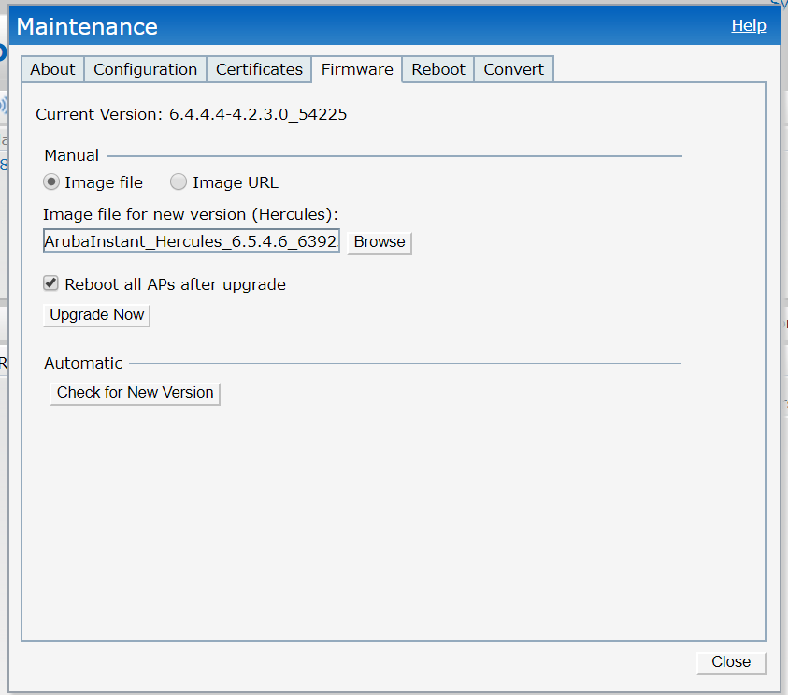

  - Click on the ‘Browse’ button, from the firmware tab.
    - Then navigate to the: I:\Infrastructure Admin\Aruba Wireless\Documentation\Lab\Setup_Notes\Aruba_AP\10232018\Version_65\ArubaInstant_Hercules_6.5.4.6_63925 - file
  - Check the box to ‘Reboot all APs after upgrade’.
  - When ready, click the button ‘Upgrade Now’ button.

- The upgrade process should complete in about 20 seconds and the AP will automatically reboot.
  - Watch the AP reboot and monitor the continuous pings from your computer.

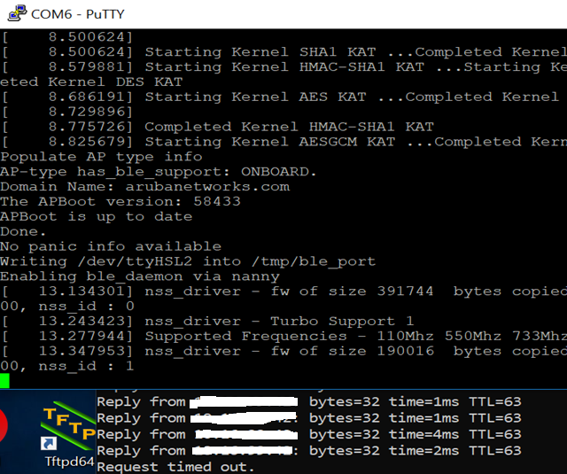

  - I have noticed that the Access Point will be ready to login again in about 3 minutes and 30 seconds.
  - You will see ping replies before the Access Point is available to be logged on again.

- When ready brows to the Access Points IP address again and login to the WEB User Interface.
  - Click on the ‘Maintenance’ link located in the upper right-hand corner of the UI.
  - Click on the ‘Convert’ tab, to see the currently installed image version.

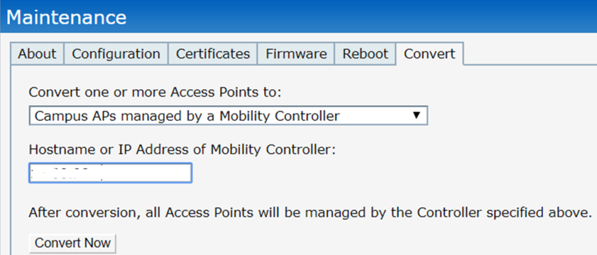

  - Type the IP address the ‘leader’ – Local Aruba Controller in the field above.
  - When ready, please click on the ‘Convert Now’ button.
  - Then click on the red ‘Convert Now’ button to confirm.

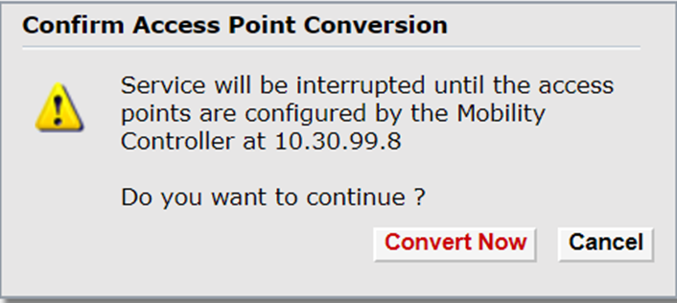

- It will take approximately 25 seconds to complete the conversion and the AP will automatically reboot.

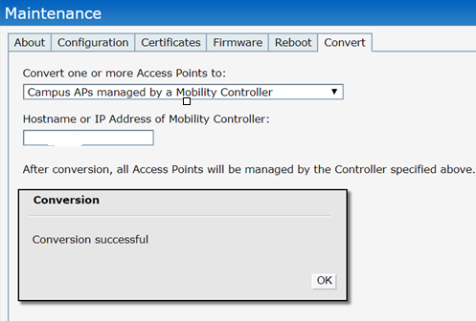

- Monitor the reboot and continuous pings.
  - I have seen the pig replies begin about 1 minute and 20 seconds after the conversion.
  - But the boot up process is still continuing and the Access Point will be recognized from the Mobility Master after approximately 2 minutes and 30 seconds.
  - One will not be able to login to the Access Point after it is converted to Campus mode.

- One may watch the Mobility Master and refresh the web page to view the new AP
  - MM – Managed Network – Dashboard – Access Points.
  - Or run a command >show ap database<enter> from the MM.

- After your AP is converted into Campus Mode, it will be in the ‘Managed Network’ default group.

